PRESS INFORMATION

JANUARY 2020

No tangled cables at all -
Secure presentation of tablets & Co.
Solutions for energy distribution in media shelves

Touch it and try it out - this is how stationary trade can score points and offer the end consumer real added value. Customers particularly like to test smartphones, tablets and other small electrical appliances before buying. To do so, they must be connected to the retailer's power and data supply in a stable manner. Wieland Electric is presenting a tailor-made and above all secure plug & play solution for power distribution in media shelves and tables at the Euroshop in Düsseldorf.

Consumer electronics stores use media tables and shelves to present and demonstrate their small electrical appliances. All too often, these presentation areas are still supplied via interlinked multiple sockets - which often looks chaotic and is also prohibited. Because this type of cabling means that fuse elements can no longer be triggered safely, and there is an increased risk of fire.

This is different with the modular and pluggable system from Wieland Electric, whose components are all industrially prefabricated. Pluggable multiple sockets ensure a simple and safe power supply with a connection level according to DIN EN 61535. The connected consumers are specially protected by a fine surge protection. The pluggable components also help the dealer to save time and money. This is because both initial installation and conversion or expansion are quick, simple and flexible.

Wieland at EuroShop in Düsseldorf
You will be able to experience these and many other tailor-made solutions from Wieland Electric for the retail trade in practical terms at EuroShop from 16 to 20 February (Hall 9, Stand B 44) in Düsseldorf.

IMAGE MATERIAL

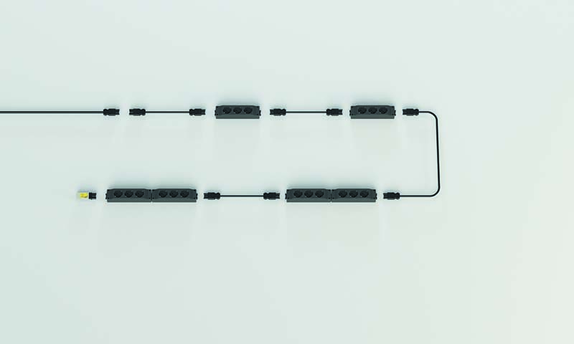
Application example media shelf

ABOUT WIELAND ELECTRIC

Wieland Electric, founded in Bamberg in 1910, is the inventor of safe electrical connection technology. Today, the family-owned company is one of the leading suppliers of safety and automation technology and has been the global market leader in the field of pluggable electrical installations for building technology for over 30 years.

Wieland Electric assists customers with on-site support all over the world as a capable service partner and solution provider. This is possible thanks to around 1,600 employees and subsidiaries as well as sales organizations in over 70 countries. In addition to Wieland Electric GmbH, STOCKO Contact GmbH & Co. KG has belonged to Wieland Holding since 1998.

The core industries of the company are machine building, wind power, and building and lighting technology. The broad portfolio includes components, products, and solutions for electrical installation, connection technology, power distribution, safety technology, and the control cabinet. In addition, Wieland Electric offers an extensive service and training program. With cross-industry experience, great product diversity, and numerous service offerings, the company has consistently developed from a component supplier into a solution provider in recent years.

PRESS CONTACT
WIELAND ELECTRIC GMBH Sabine Eyler
Marketing Communication E-Mail: info@sabine-eyler.de
Brennerstraße 10 – 14 Phone: 0049 9285 961869
96052 Bamberg · Germany
E-Mail: communications@wieland-electric.com
Internet: www.wieland-electric.de

