SUCCESS STORY

FULL POWER FOR HEALTH
Wieland Electric supplies pluggable electrical installation system for new building of Royal Sussex County Hospital in England

It is a milestone in the extensive renovation work at the Royal Sussex County Hospital in Brighton, England: the Louisa Martindale Building. The new facility not only provides world-class medical treatment and care, but also meets the highest standards of patient comfort and efficiency. Wieland Electric is responsible for the power supply and lighting of the eleven-story building. The company, headquartered in Bamberg, Franconia, supplied a modular cabling system for the major project, which enables rapid and safe installation thanks to its universal pluggability.

The Wieland Electric system, designed according to the plug & play principle, is industrially prefabricated to the highest possible degree and all products are delivered unit-tested. In this way, installation times can be significantly reduced and tight deadlines are met. The Wieland solution used for the Louisa-Martindale building is suitable for both power distribution and lighting control, including DALI and KNX. In addition, it is possible to adapt individual components for individual projects, which contributes to a high degree of flexibility. Thanks to the modularity and pluggable connections, changes to the system can also be made quickly and with minimal downtime, which is particularly important for hospitals.

IMAGE MATERIAL

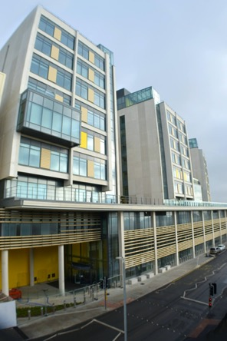
The eleven-story Louisa Martindale building at the Royal Sussex County Hospital in Brighton, England, was completed in spring 2023. The electrical infrastructure for power and lighting was provided by Wieland Electric. (Image: supplied by Richard Beard, Head of Communications (3Ts and Capital))

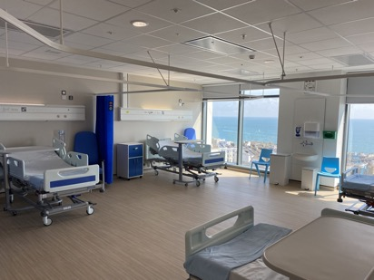
The new clinic building is characterized by a high level of patient comfort and is equipped with efficient technologies. Thanks to the pluggability of the Wieland system, the installation of the electrical infrastructure could be implemented quickly.

(Image supplied by Richard Beard, Head of Communications (3Ts and Capital))

+ if possible picture motif of the product used, if applicable one of the connectors used?
I don’t have an image of the connectors used.

PRESS CONTACT
Heather Giffard
Sales & Marketing Administrator
Phone: +44 (1483) 531213
E-mail: heather.giffard@wieland-electric.com

ABOUT WIELAND ELECTRIC

Wieland Electric, founded in Bamberg in 1910, is the inventor of safe electrical connection technology. Today, the family-owned company is one of the leading suppliers of safety and automation technology and has been the global market leader in the field of pluggable electrical installations for building technology for over 30 years.

Wieland Electric assists customers with on-site support all over the world as a capable service partner and solution provider. This is possible with around 1,600 employees and subsidiaries with sales organizations in over 70 countries. In addition to Wieland Electric GmbH, STOCKO Contact GmbH & Co. KG has belonged to Wieland Holding since 1998.

The core industries of the company are mechanical engineering, wind power, and building and lighting technology. The broad portfolio includes components, products, and solutions for electrical installation, connection technology, power distribution, safety technology, and the control cabinet. In addition, Wieland Electric offers an extensive service and training program. With cross-industry experience, a great product diversity and numerous service offerings, the company has consistently developed from a component supplier to a solution provider in recent years.

