PRESS INFORMATION

RETROFIT FOR THE SAFE CONTINUED OPERATION OF WIND TURBINES

WIELAND ELECTRIC SUPPORTS WIND TURBINE OPERATORS WITH COMPLETE SYSTEM FOR EASY RETROFITTING OF WORK AND SAFETY LIGHTING

Many wind turbines (WTG) will lose their entitlement to remuneration under the Renewable Energy Sources Act (EEG) this year. This initially applies to turbines with a total output of just under 4,000 megawatts. Until 2025, additional wind turbines with an average of up to 2,400 megawatts will follow annually. However, even after their remuneration period has expired, the benefits of these turbines are considerable, partly due to their contribution to climate protection and the conservation of resources through the use of existing infrastructure. In good wind locations, wind turbines can continue to operate for years even after they have reached their design life of 20 years and are depreciated.

The condition of all components relevant to stability and the functionality of the safety equipment, turbine control and braking systems are decisive for such continued operation. The framework conditions for this are defined in the principles for carrying out an assessment and inspection of the continued operation of onshore wind turbines (BPW). The working and safety lighting of the wind turbine is also part of the tests. Here, Wieland Electric supports plant operators with a complete system that can be retrofitted quickly and easily without having to dismantle the existing lighting.

It is a centrally supplied safety lighting system based on a secondary voltage of 48VDC (SELF) or normal mains voltage of 230V AC, providing at least 30 minutes of buffering after a mains failure. Longer times can be achieved with stronger batteries. In contrast to outdated technology where the batteries were installed in the luminaires, Wieland Electric offers a central battery solution as well as modern, safe LED technology that can be easily maintained. Optionally, a light simulation including documentation of the lighting values at the workplaces and escape routes can also be carried out.

IMAGE MATERIAL
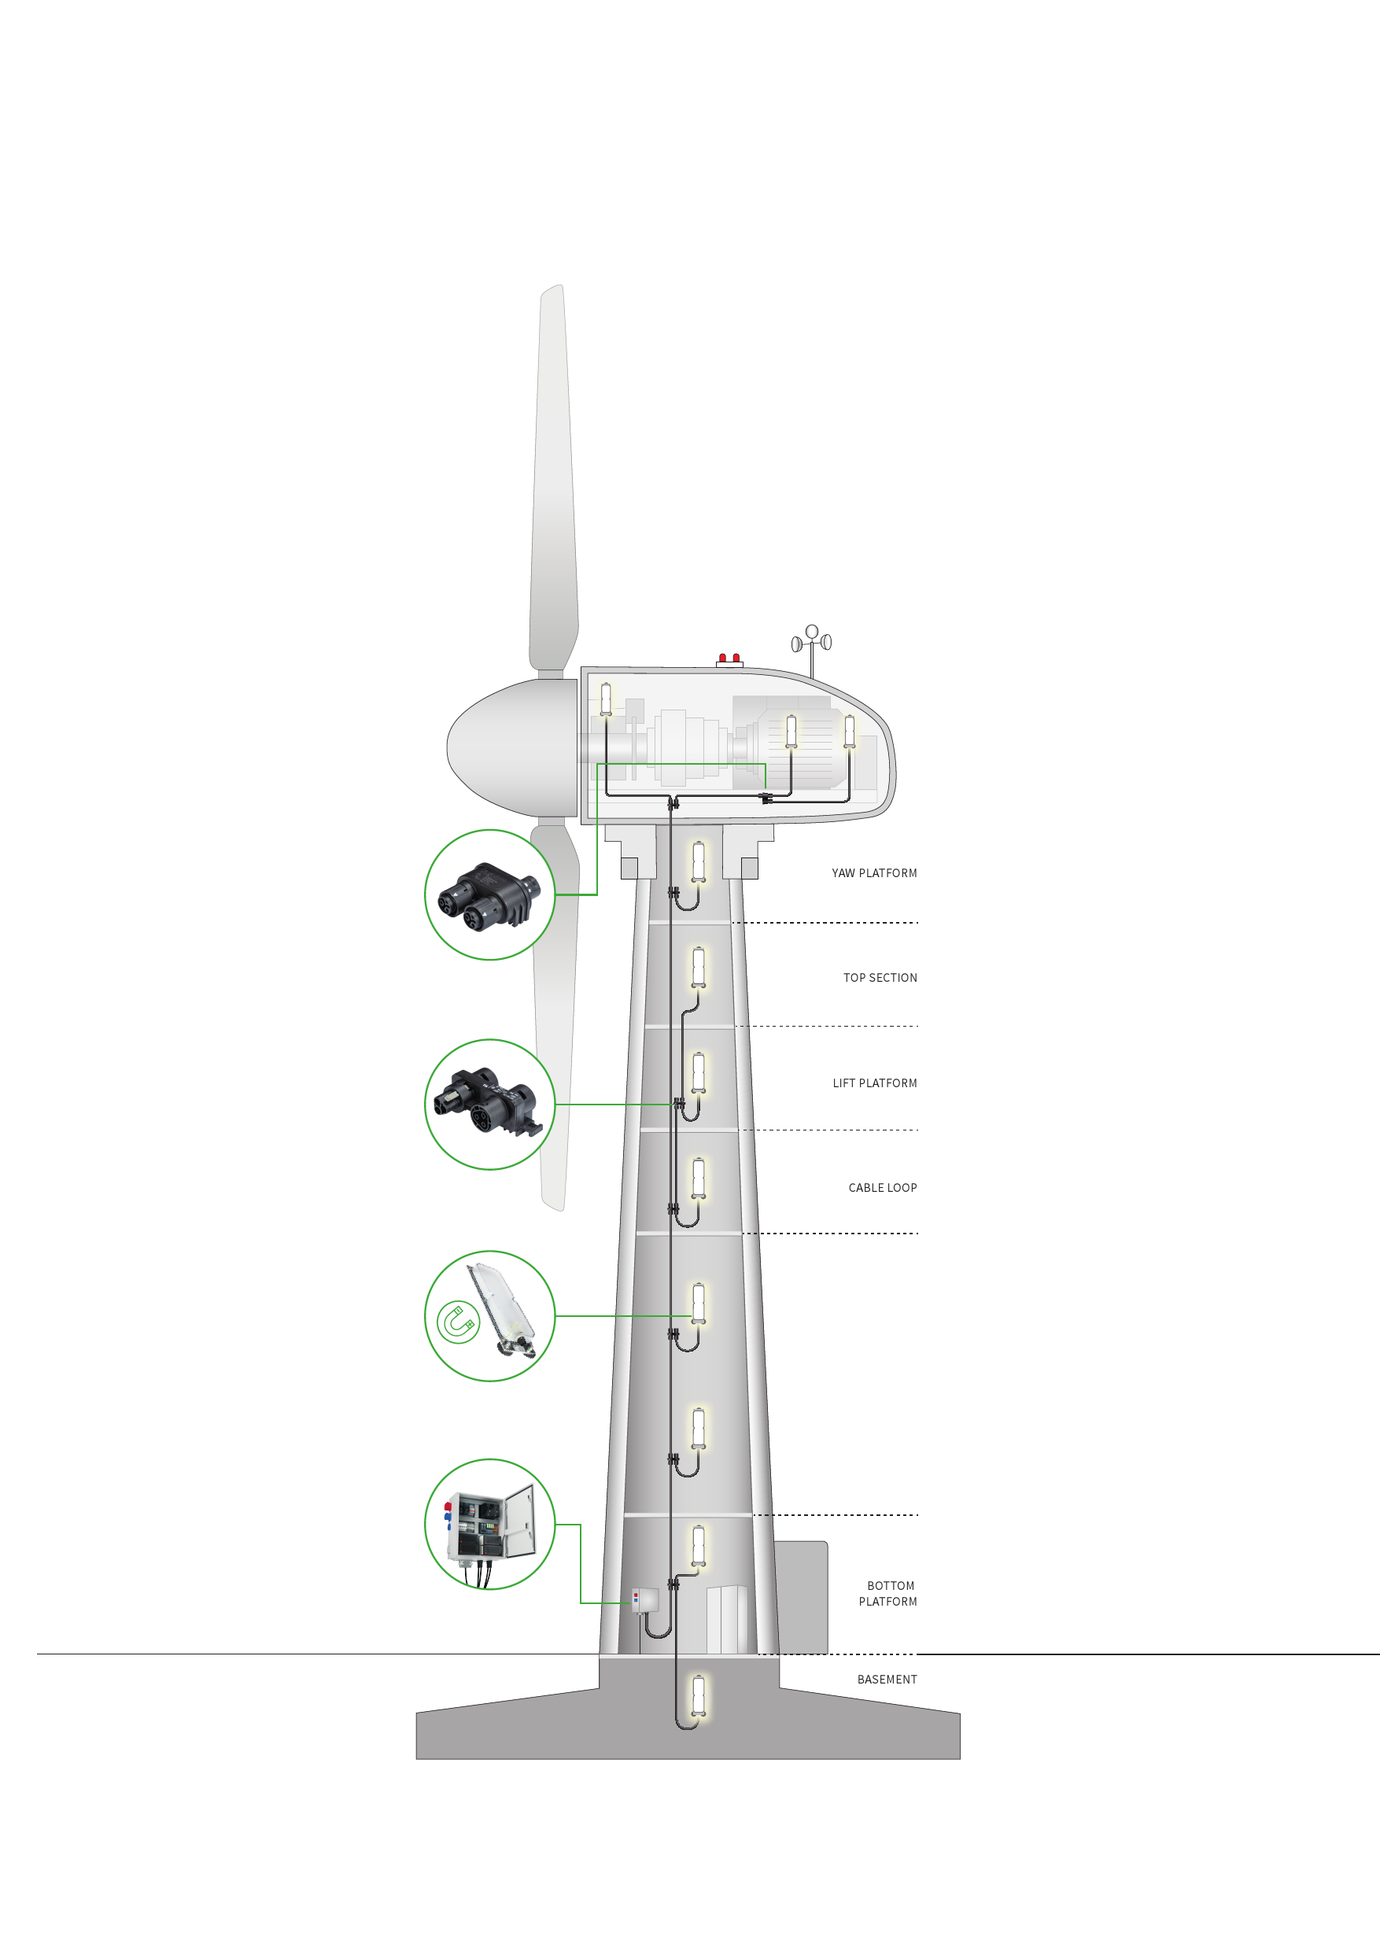

ABOUT WIELAND ELECTRIC

Wieland Electric, founded in Bamberg in 1910, is the inventor of safe electrical connection technology.
Today, the family-owned company is one of the leading suppliers for safety and automation technology
and has been the world market leader in the field of pluggable electrical installation for building technology for over 30 years.

Wieland Electric supports customers worldwide on site as a competent service partner and solution provider.
This is possible with around 1,600 employees and subsidiaries as well as sales organizations in over 70 countries. In addition to Wieland Electric GmbH, since 1998 STOCKO Contact GmbH & Co. KG has been part of the Wieland holding company since 1998.

The company's core industries include mechanical engineering, wind power, intralogistics and HVAC as well as
building and lighting technology. The broad portfolio includes components, products and solutions for electrical installation, connection technology, power distribution, safety technology and the control cabinet. In addition, Wieland Electric offers an extensive service and training program. With cross-industry experience, a wide range of products and numerous service offerings, the company has consistently developed from a component provider to a solution provider in recent years.

PRESS CONTACT

WIELAND ELECTRIC GMBH
Alexander Viertmann / Communications Manager
Phone: +49 951 9324 316
E-Mail: communications@wieland-electric.com
Internet: www.wieland-electric.de

MARION NIKOL
KOMMUNIKATION FÜR INDUSTRIE & TECHNOLOGIE
Phone: +49 170 2731025
E-Mail: info@intecsting.de
Internet: www.intecsting.de

