PRESS RELEASE

ROBUST SWITCH FOR USE IN THE FIELD

The new IP67 switch from Wieland Electric enables reliable operation even under the most adverse environmental conditions

Modular and flexible machine concepts are growing rapidly in importance. In the course of this development, automation components are increasingly being connected in a decentralized manner. This also applies to IP switches, which are no longer only mounted in the control cabinet, but also directly on the machine. In order to ensure reliable operation of the network components under these circumstances, the devices must meet high requirements. After all, they are directly exposed to potentially harmful influences such as dust, moisture and electromagnetic radiation. Wieland Electric offers a suitable solution for this with its new IP67 switch.

The wienet IP-SWITCH UMS 8-W-M12 is equipped with a robust metal housing and can therefore be used under the most adverse environmental conditions. Splash water, contamination and high temperatures up to 75° Celsius are handles without any problems. In addition, the switch complies with the EN 50155 standard, making it suitable for the harsh requirements of railroad applications. Fluctuations and interruptions in the power supply are tolerated, as are vibrations, shocks and high relative humidity. The compact device is easy to maintain and features a long service life and high electromagnetic compatibility (EMC).

The plug & play feature of the new IP67 switch from Wieland Electric enables fast commissioning even without programming experience. Sensors and actuators can be connected robustly and reliably via eight M12 Fast Ethernet ports, which contributes to low failure rates. Its compatibility in conjunction with programmable logic controllers (PLCs) within the IEC 61131-2 framework also ensures reliable network operation with the lowest probability of failure.

Optimally suited for modular systems: The robust and compact IP67 switch from Wieland Electric ensures reliable operation even in harsh environmental conditions.

IMAGE MATERIAL

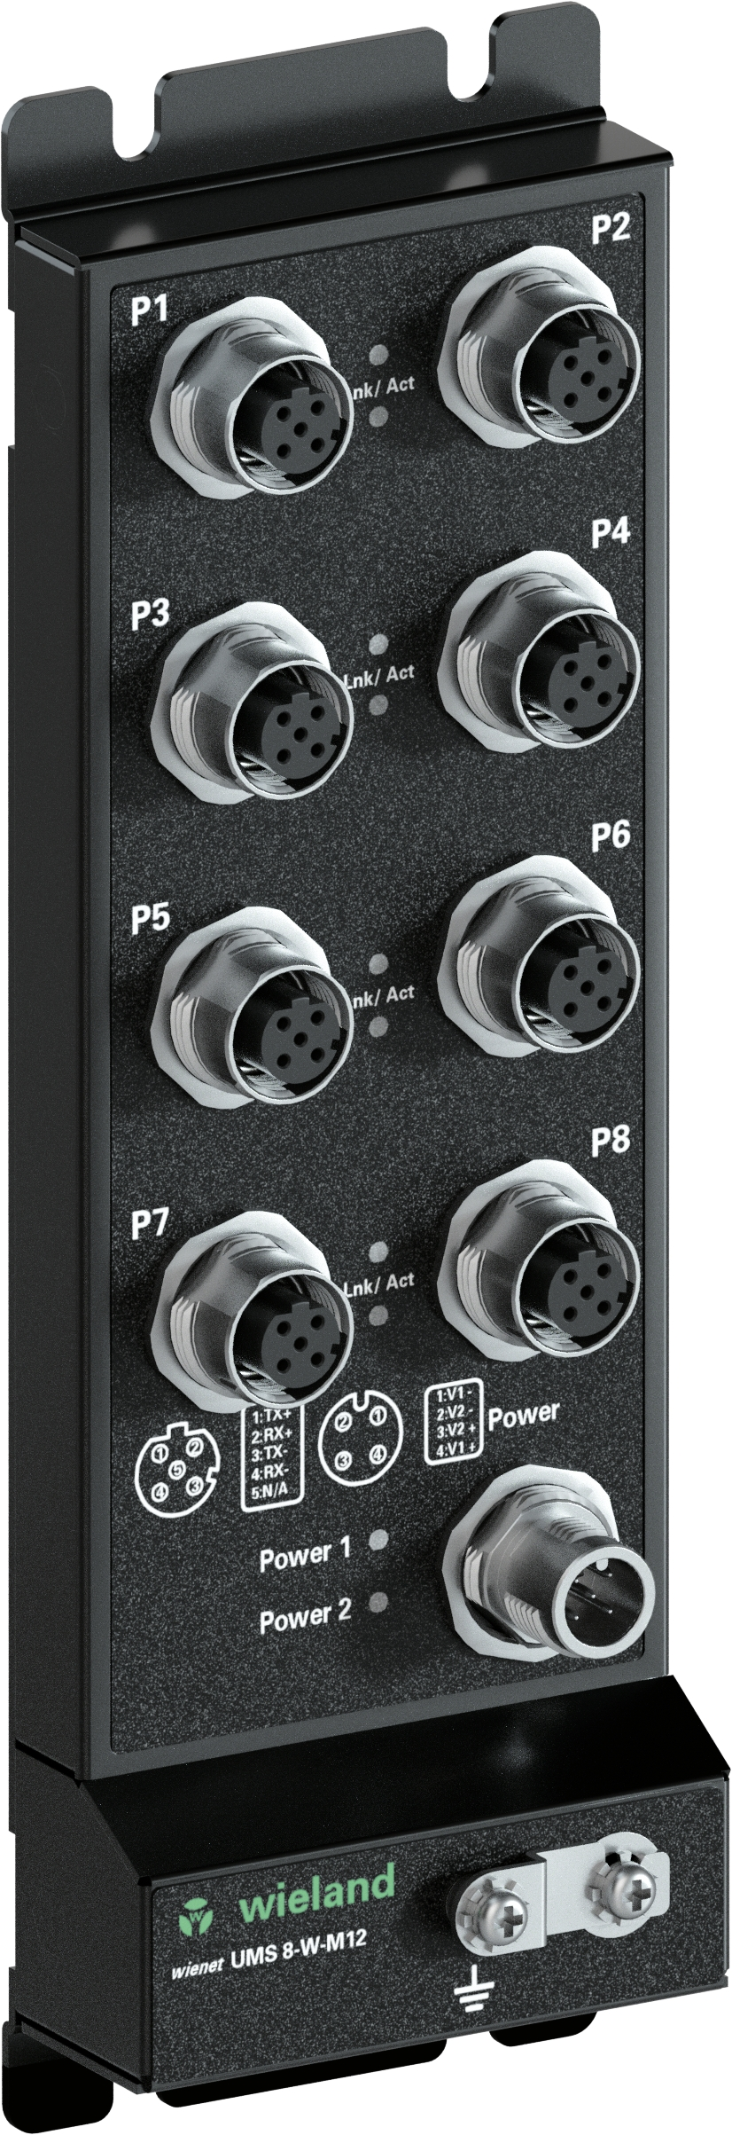

Product details & technical data

IP-SWITCH WIENET UMS 8-W-M12 Unmanaged Switch 8xM12 Fast Ethernet (10/100 Mbit/s) ports, IP 67, wide temperature range
Ethernet standards IEEE: 802.3/802.3u/802.3x
Voltage type: DC
Min. operating temperature: -40 °C
Max. Operating temperature: 75 °C
Storage temperature / transport min: -40 °C
Storage temperature / transport max: 85 °C
Relative humidity min. : 5 %
Relative humidity max: 95 %
Net weight: 700 g
Redundant power supply: 2 power inputs
Standards and approvals: IEC 61131-2, EN50155

ABOUT WIELAND ELECTRIC

Wieland Electric, founded in Bamberg in 1910, is the inventor of safe electrical connection technology. Today, the family-owned company is one of the leading suppliers of safety and automation technology and has been the global market leader in the field of pluggable electrical installations for building technology for over 30 years.

Wieland Electric assists customers with on-site support all over the world as a capable service partner and solution provider. This is possible thanks to around 1,600 employees and subsidiaries as well as sales organizations in over 70 countries. In addition to Wieland Electric GmbH, STOCKO Contact GmbH & Co. KG has belonged to Wieland Holding since 1998.

The company’s core industries are mechanical engineering, wind power, intralogistics, HVAC and
building and lighting technology. The broad portfolio includes components, products and solutions for electrical installation, connection technology, power distribution, safety technology and the control cabinet. In addition, Wieland Electric offers an extensive service and training program. With cross-industry experience, a great product diversity and numerous service offerings, the company has consistently developed from a component supplier to a solution provider in recent years.

PRESS CONTACT

WIELAND ELECTRIC GMBH
Alexander Viertmann / Marketing Communication
Phone: +49 951 9324 316
E-mail: communications@wieland-electric.com
Internet: www.wieland-electric.de

