PRESS RELEASE

IMPORTANT PIECE OF THE PUZZLE FOR MODULAR BUILDING
"80 Seconds - New Building" Summit in Berlin: High need for serial building and great demand for clever installation solutions like Wieland PREFAB

In Germany, 400,000 new apartments are to be built each year. This means that a new apartment would have to be completed every 80 seconds in Germany. How this can be achieved was recently discussed at the "80 Seconds - New Building" Summit in Berlin. For the first time, the networking event brought all decision-makers and innovators from politics, the construction and real estate industries together at one table in the Gartenfeld Quarter in Berlin to develop solutions for change in the construction industry.

As it turned out at the summit, the federal government's goal is only feasible and affordable through serial construction with industrially manufactured elements and modules. A decisive role is also played by the electrical installation, which can be optimally integrated into the prefabrication with the help of the new PREFAB system from Wieland Electric. Fortunately, the Bamberg-based technology company was given the opportunity to present the advantages of its solution at the event via its cooperation partner JUNG (Albrecht Jung GmbH): Deniz Turgut, Head of Marketing at JUNG, showed in his keynote speech how the pluggable, industrially prefabricated electrical installation systems support speedy and error-free assembly, reduce time-consuming work on the construction site and contribute to savings in time, personnel and resources.

The response of the participants was correspondingly positive, as Thomas Nieborg, Product Information Manager, and Peter Kauf, Head of Strategic Project Infrastructure/Prefab at Wieland Electric, report: "In fact, all of the discussion partners told us that they had been literally waiting for our solutions for effective, fast, error-free and digitally plannable electrical installation. This starts with end-product manufacturers who want to deliver their equipment in pluggable form in the future and extends to manufacturers who want to integrate our solutions into their concrete elements."

In addition to well thought-out installation concepts, digitization also plays a key role in the transformation of the construction industry. With PREFAB, Wieland is also in tune with the times and, with the help of digital tools, contributes to smooth and more predictable construction processes. "With PREFAB, we are breaking new ground in many respects," says Peter Kauf, who explains the new Wieland business model as follows: "In addition to solutions tailored precisely to the requirements of modular and serial construction, we offer support for architects, planners and construction companies in all construction phases - from the first concept to commissioning. To that end, we're also driving digitization to make it easy to configure the solutions and integrate them into a BIM design, and deliver the customer the right products at the time they need them in their process."

IMAGE MATERIAL
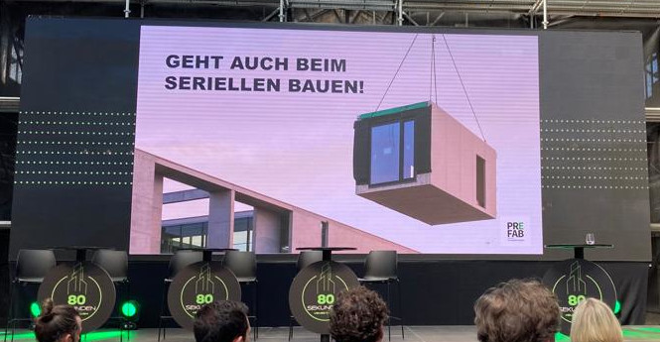

The "80 Seconds - New Building" summit recently brought together more than 1,100 guests - including decision-makers from the construction and real estate industries as well as top politicians - in the German capital. In his keynote speech, Deniz Turgut, Head of Global Marketing at Albrecht Jung GmbH (JUNG), also discussed the advantages of the Wieland PREFAB system.

PRESS CONTACT
Magdalena Montagna
Content Marketing & Communication
Phone: ++49 (951) 9324 - 316
E-mail: magdalena.montagna@wieland-electric.com

ABOUT WIELAND ELECTRIC

Wieland Electric, founded in Bamberg in 1910, is the inventor of safe electrical connection technology. Today, the family-owned company is one of the leading suppliers of safety and automation technology and has been the global market leader in the field of pluggable electrical installations for building technology for over 30 years.

Wieland Electric assists customers with on-site support all over the world as a capable service partner and solution provider. This is possible thanks to around 1,600 employees and subsidiaries as well as sales organizations in over 70 countries. In addition to Wieland Electric GmbH, STOCKO Contact GmbH & Co. KG has belonged to Wieland Holding since 1998.

The core industries of the company are mechanical engineering, wind power, and building and lighting technology. The broad portfolio includes components, products, and solutions for electrical installation, connection technology, power distribution, safety technology, and the control cabinet. In addition, Wieland Electric offers an extensive service and training program. With cross-industry experience, a great product diversity and numerous service offerings, the company has consistently developed from a component supplier to a solution provider in recent years.

