OCTOBER 2022
PRESS INFORMATION

WIELAND ELECTRIC MEETS BROSE BAMBERG

TRADITIONAL BAMBERG COMPANY ENTERS INTO PARTNERSHIP WITH BAMBERG SPORTS GREAT

On Sunday, October 2, 2022, the moment had come. The new partnership between Wieland Electric GmbH and Brose Bamberg was officially launched with the ceremonial inauguration of the new Wieland SportsLounge. During the opening game against Alba Berlin, Managing Director Dr. - Ing, Börne Rensing and Division Manager Marketing Dagmar Dittmann opened the SportsLounge together with family, business partners and also some Wieland employees.

„Wieland meets Brose Bamberg! As a Bamberg-based company and world market leader in pluggable electrical connection technology, we are particularly pleased to be able to play a part in Brose Bamberg's sporting success. Team Brose Bamberg has a passionate fan base and, like us, is ambitious and goal-oriented, internationally active but at the same time regionally rooted. We are therefore very much looking forward to talking to the fans and the crowd at the Wieland Sportslounge in the coming years - Dagmar Dittmann.“

In addition, Anika Lunz, an employee in Human Resources, took on the Lotto Bayern halftime challenge and, by hitting two out of three baskets, earned €400 for the homeless charity. Wieland Electric took this as an opportunity to also donate €600 to Freak City e.V. to specifically support sports projects in the Bamberg region.
From now on, the SportsLounge will be open at every home game to welcome guests with delicious food, refreshing drinks and the opportunity to network.

IMAGE MATERIAL

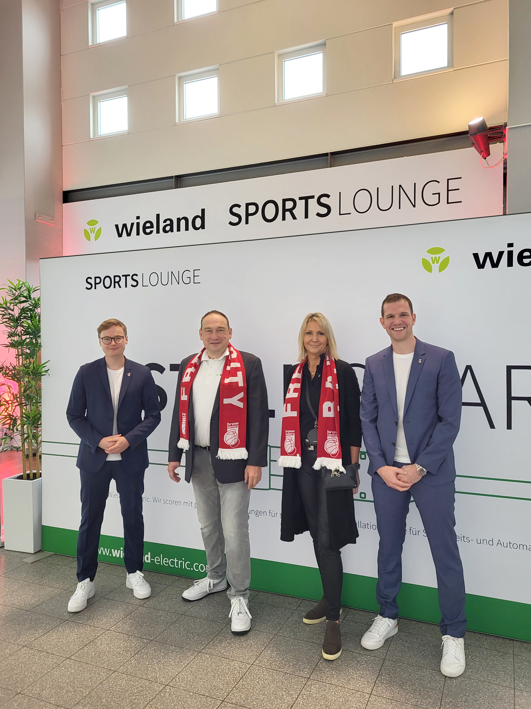

(left to right: Fabian Ahlmer, Börne Rensing, Dagmar Dittmann, Philipp Höhne)

ABOUT WIELAND ELECTRIC

Wieland Electric, founded in Bamberg in 1910, is the inventor of safe electrical connection technology.
Today, the family-owned company is one of the leading suppliers for safety and automation technology
and has been the world market leader in the field of pluggable electrical installation for building technology for over 30 years.

Wieland Electric supports customers worldwide on site as a competent service partner and solution provider.
This is possible with around 1,600 employees and subsidiaries as well as sales organizations in over 70 countries. In addition to Wieland Electric GmbH, since 1998 STOCKO Contact GmbH & Co. KG has been part of the Wieland holding company since 1998.

The company's core industries include mechanical engineering, wind power, intralogistics and HVAC, as well as building and lighting technology. The broad portfolio includes components, products and solutions for electrical installation, connection technology, power distribution, safety technology and the control cabinet. In addition, Wieland Electric offers an extensive service and training program. With cross-industry experience, a wide range of products and numerous service offerings, the company has consistently developed from a component provider to a solution provider in recent years.

PRESS CONTACT
WIELAND ELECTRIC GMBH
Alexander Viertmann / Marketing Communication
Telefon: +49 951 9324 316
E-Mail: communications@wieland-electric.com
Internet: www.wieland-electric.com

