JANUARY 2025

PRESSINFORMATION

E-charging infrastructure easy to set up

**Wieland Electric expands electrical installation system for**

**charging stations with new components for greater safety and flexibility**

A comprehensive charging infrastructure plays a key role in the integration of electric vehicles into everyday life. There is a great need for action, especially in parking garages and underground garages. As Wieland Electric will be demonstrating at BAU 2025, there is a well thought-out complete solution for this that makes setting up an e-charging infrastructure extremely easy and ensures maximum flexibility and safety thanks to new components.

With the podis® flat cable system from Wieland Electric, up to 20 charging stations can be connected via just one supply line. This significantly reduces the installation effort, saves material costs and minimizes the size of the required distribution cabinet. It also creates the basis for easy retrofitting of additional charging stations during the initial installation. Once the flat cable has been installed, it is sufficient to integrate a further connection module if required - a decisive advantage over conventional installation methods that saves time and money.

**Convenient integration of protective devices**

Wieland Electric offers a convenient solution in the form of the fuse module to meet the normative safety requirements of every final circuit. The fuse module combines the connection to the flat cable and the integration of DIN rail mounted devices. Variants with integrated FI/LS or LS are available for electromobility. As the internal wiring is prefabricated at the factory, the module only needs to be connected to the flat cable on site. With the RST® system from Wieland Electric, the outlet to the charging station can be designed to be pluggable. This eliminates the considerable installation effort that would be required with a separate, conventionally wired fuse box and outgoing cable.

In addition to the standard variants, Wieland Electric offers the option of customizing the fuse module. Based on the 5G6 or 5G16 system, four partition units offer space for the integration of completely pre-wired line, residual current, maintenance or motor-protective circuit-breakers. Various top and bottom parts allow the selection of different outputs in pluggable or conventional design with cable gland to the load. As usual with Wieland Electric, the pluggable outputs have different mechanical codings to prevent incorrect plugging and increase safety.

**Even easier attachment**

Time-saving and easy handling characterize the fastening of the podis® system. At BAU 2025, Wieland Electric will be showcasing a new fastening clamp for highly efficient installation. The clamp consists of just one component, with the upper and lower parts connected by a flexible plastic band. This makes handling easier and reduces the number of parts required.

Installation is time-saving with just one fixing point - only a single drill hole and therefore only one screw or nail is required. The clamp can also be closed without additional tools: The upper part is simply pressed down using a snap-in catch. Both screws and nails can be used for fastening, with the integrated HILTI geometry ensuring compatibility with HILTI setting tools. Thanks to a wide range of accessories, the new clamp can be easily mounted on mesh ducts or cable trays. In addition, the product offers a connection for pipe clamps, which enables parallel laying of pipes for data cables.

**Adaptable system**

Also new in the portfolio is a new module with double output, which makes it possible to operate two consumers with just one tap, thus saving one outgoing module. The module with double output can alternatively be used as a variant with an integrated top-hat rail, which has been specially designed for self-wiring. This allows components to be flexibly mounted and individually wired, making the system particularly adaptable and user-friendly.

“Whether parking garages or underground garages - with our podis® flat cable system, we not only enable user-friendly, quick and easy project planning in the field of e-charging infrastructure, but also considerable time savings during initial installation thanks to error-free and safe assembly. When it comes to expansions, the time savings are even more noticeable thanks to the high level of flexibility and simple handling,” explains Frank Nagengast, Product Information Manager at Wieland Electric.

**Wieland Electric at BAU 2025**

**January 13 to 17, 2025**

**Munich Trade Fair**

**Hall A2 Stand 439**

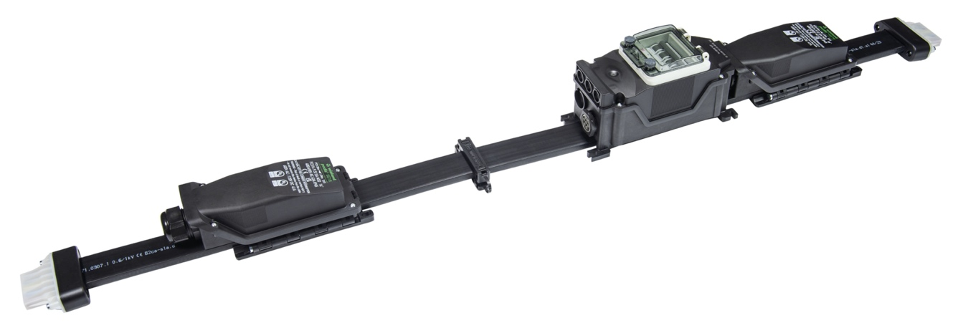

***Image 1: Wieland Electric has added new components to its podis® system to make the installation of e-charging infrastructures in parking garages and underground parking lots even easier and safer. (Image: Wieland Electric).***

PRESS CONTACT

Daniela Kapitz

Marketing Manager Communications & PR

Telephone: +49 (951) 9324 – 291

E-Mail: daniela.kapitz@wieland-electric.com

EDITORIAL OFFICE

Lisa-Marie Niehoff

b&t bau & technik PR und Werbung GmbH

Telephone: +49 211 6707-450

E-Mail: lisa-marie.niehoff@bt-pr.de

ABOUT WIELAND ELECTRIC

Wieland Electric, founded in Bamberg in 1910, is the inventor of safe electrical connection technology. Today, the family-owned company is one of the leading suppliers of safety and automation technology and has been the world market leader in the field of pluggable electrical installations for building technology for over 40 years. Wieland Electric assists customers with on-site support all over the world as a capable service partner and solution provider. This is made possible by around 1,700 employees and subsidiaries as well as sales organizations in over 70 countries. In addition to Wieland Electric GmbH, STOCKO Contact GmbH & Co. KG has belonged to Wieland Holding since 1998. The core industries of the company are mechanical engineering, wind power, and building and lighting technology. The broad portfolio includes components, products and systems for electrical installation, connection technology, power distribution, safety technology, control cabinets and industrial prefabricated construction. In addition, Wieland Electric offers an extensive service and training program. With cross-industry experience, a wide range of products and numerous service offerings, the company has consistently developed from a component supplier to a system provider in recent years.

Wieland Electric GmbH

Brennerstrasse 10-14

96052 Bamberg

Deutschland

Phone: +49 (0)952-9324-0

Mail: [info@wieland-electric.com](mailto:info@wieland-electric.com)