St. Peter’s Basilica shines in a new light
New interior lighting installed in just a few days

Every year, millions of people admire St. Peter’s Basilica in Rome. With its new interior lighting, it has now become even more radiant. The installation work at a height of up to 110 m was completed in just a few days without any cordons and without impacting on the throngs of visitors. The innovative connection technology that made this possible came from Germany’s Wieland Electric.

St. Peter’s Basilica is the center of Roman Catholic Christianity, the destination and source of strength for believers from around the world, and it is home to countless great works of art. These will now be able to shine even more thanks to a new and innovative lighting system from Osram. As will the unique architecture inside the church itself. For this purpose, some 100,000 LEDs were installed in 780 special luminaires, and almost 20 km of cable laid. The installation was a mammoth project that required careful planning. Any restrictions or even a closure had to be avoided as far as possible, while ensuring the safety of workers and visitors to the greatest possible extent as the installation also involved the dome of the cathedral, which meant working at a considerable height. For these reasons, the Vatican opted for the pluggable and therefore innovative connection technology of Wieland Electric GmbH.

Plug&play - Easy, quick, and safe to install
Wieland’s universally pluggable modular system, from the distributor to the luminaire connection, consists of components which have been prefabricated and tested at the factory. This means that the connection technology can already be planned in detail in advance. The cables were delivered pre-assembled with the correct length and labeled for their respective place of use. The assembly times in St. Peter’s Basilica itself could therefore be reduced by around 70 percent compared with conventional installation. It took just a few days to complete the installation of the new lighting system. The plug & play approach replaced labor-intensive wiring and was also a real plus in terms of safety, as Stephan Lauer, who is responsible for global lighting and building projects at Wieland, points out: “It was installed during ongoing operation while nearly 30,000 people visited St. Peter’s Basilica daily. Dropping a screwdriver from a height here does not bear thinking about. This danger was minimized because our system can be installed without using any tools.” The operation involved GST18 and RST20 plug connectors and device connectors (3-pole and 5-pole for luminaires dimmable with DALI), supplemented with distribution elements, cable assemblies, and accessories.

Reliable moisture protection for outdoor installation in St. Peter’s Square
The new interior lighting is not the first project that the Vatican, Osram, and Wieland have realized together. St. Peter’s Square has already been shining in a new light since summer 2016. That project too involved Wieland’s pluggable connection technology, which also impresses outdoors with its reliable moisture protection. To prevent even heavy rain in St. Peter’s Square from causing a single luminaire to go out, RST plug connectors and device connectors which boast comprehensive IP protection (IP66, IP68, IP69) were chosen.

Photos

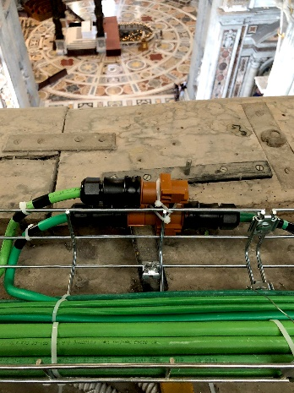
A special Italian cable with a particularly large outside diameter – this too can be used with Wieland’s GST18i5 or also RST20 connectors.

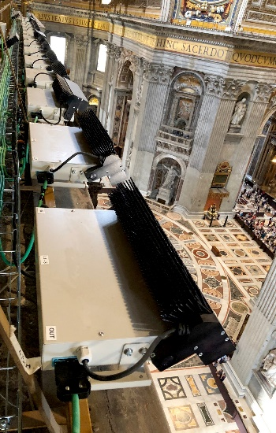
Installation work at a considerable height – this is easy, quick, and safe with Wieland’s pluggable components, which are handled without using tools.

