PRESS INFORMATION

JANUARY 2020

Making better use of space –
New ideas for infrastructure cabling in retail from Wieland Electric

Retail space today must be one thing above all: flexible! Unfortunately, this flexibility all too often reaches its limits when electrical or data cables also have to be moved. At the EuroShop in Düsseldorf, Wieland Electric will show how innovative infrastructure cabling in the store can meet these new requirements.

The refrigerated counter has to make room for the new action area, the illuminated display has to move further forward and the decoration still needs electricity - sounds elaborate? But it doesn't have to be if the smart pluggable system from Wieland Electric is used!

Completely pluggable and without junction boxes, it provides energy flexibly at any position in the sales room. Flat cables, which are routed along the walls and also in the ceiling or floor, serve as conductor rails. Lighting and cooling are supplied separately.
Temporary superstructures, decorations or secondary placements can thus be realised easily, quickly and without installation work anywhere on the surface.

Wall profiles are the solution for displays that need to be illuminated and therefore supplied with power. They are not only used for fastening, but also automatically establish the contact for the lighting when hung up.

The smart Wieland system is not only flexible, it also saves time and money thanks to its plug-in capability. Assembly times can be reduced by up to 70 per cent compared to conventional installation. Total costs are reduced by 30 percent.

Wieland at EuroShop in Düsseldorf
You will be able to experience these and many other tailor-made solutions from Wieland Electric for the retail trade in practical terms at EuroShop from 16 to 20 February (Hall 9, Stand B 44) in Düsseldorf.

IMAGE MATERIAL

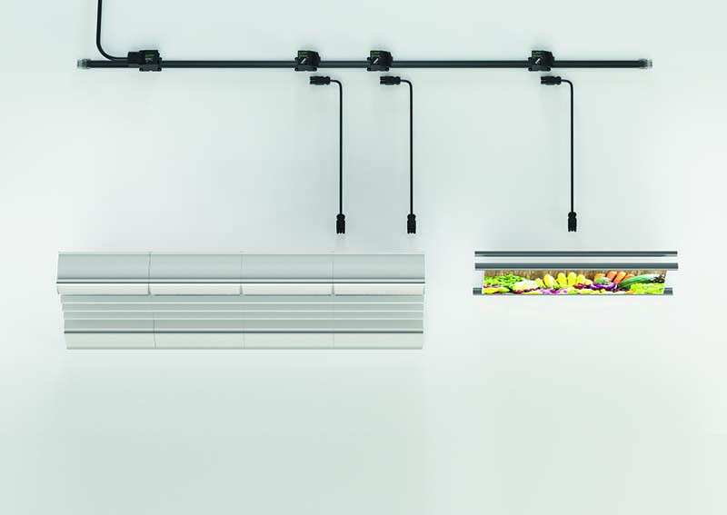
Application example infrastructure cabling

ABOUT WIELAND ELECTRIC

Wieland Electric, founded in Bamberg in 1910, is the inventor of safe electrical connection technology. Today, the family-owned company is one of the leading suppliers of safety and automation technology and has been the global market leader in the field of pluggable electrical installations for building technology for over 30 years.

Wieland Electric assists customers with on-site support all over the world as a capable service partner and solution provider. This is possible thanks to around 1,600 employees and subsidiaries as well as sales organizations in over 70 countries. In addition to Wieland Electric GmbH, STOCKO Contact GmbH & Co. KG has belonged to Wieland Holding since 1998.

The core industries of the company are machine building, wind power, and building and lighting technology. The broad portfolio includes components, products, and solutions for electrical installation, connection technology, power distribution, safety technology, and the control cabinet. In addition, Wieland Electric offers an extensive service and training program. With cross-industry experience, great product diversity, and numerous service offerings, the company has consistently developed from a component supplier into a solution provider in recent years.

PRESS CONTACT
WIELAND ELECTRIC GMBH Sabine Eyler
Marketing Communication E-Mail: info@sabine-eyler.de
Brennerstraße 10 – 14 Phone: 0049 9285 961869
96052 Bamberg · Germany
E-Mail: communications@wieland-electric.com
Internet: www.wieland-electric.de

