HANNOVER MESSE 2019 PRESS RELEASE

WIELAND ELECTRIC OFFERS NEW PRINTED CIRCUIT BOARD CONNECTORS WITH DIRECT PLUG-IN TECHNOLOGY

WIECON® 8105 DST ENABLES DIRECT CONTACT WITH THE PRINTED CIRCUIT BOARD WITHOUT ANY SOLDERING

For Hannover Messe 2019, Wieland has expanded its portfolio of printed circuit board connectors with a new, convenient, and space-saving model for establishing contact with printed circuit boards. The wiecon® 8105 DST has a direct plug-in design and can be plugged straight into the board without having to solder a pin header. This saves the user not only time during assembly but also costs, as only one component is required. The new connectors are ideal for use in heating, building, or machine controllers as well as in domestic appliances.

As the designs of control units in heating and mechanical engineering as well as in building technology and services are becoming increasingly compact, space-saving solutions are needed for the connection technology. Wieland is responding to this with the new wiecon® 8105 DST printed circuit board connector, which enables direct contact with the printed circuit board without any soldering. The direct plug-in technology saves a lot of space, offers reliable contact, and helps to save time and costs as there is no need for a pin header or multipoint plug.

The new printed circuit board connector can be arranged in a grid so there is no loss of poles with arrangement side by side. In addition, there is no need for a lead-in chamfer on the board, making it more favorable. The wire guard prevents mismating. Interchangeable inserts for codings also offer numerous coding options. The reliable clamping yoke connection technology also allows multi-core conductors to be connected. The wiecon® 8105 DST is available in 15 different colors, specifically using “no flame” plastics compliant with DIN EN 60335-1. The special contact geometry makes it possible to use boards with 1.4 to 1.8 millimeters, which means that the new connector can be used for a very broad range of applications.

(2,044 incl. spaces)

IMAGE MATERIAL

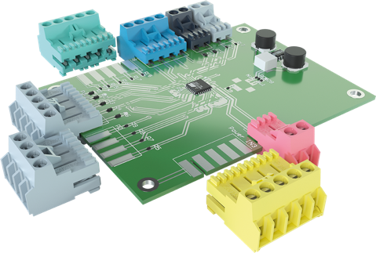
Convenient and space-saving: The new wiecon 8105 DST printed circuit board connector from Wieland Electric can be plugged directly into the board without any soldering.

PRESS DOWNLOAD SECTION
This press release can be downloaded from our website:
http://wie.li/pressehmi19

ABOUT WIELAND ELECTRIC

Wieland Electric, founded in Bamberg in 1910, is the inventor of safe electrical connection technology. Today, the family-owned company is one of the leading suppliers of safety and automation technology and has been the global market leader in the field of pluggable electrical installations for building technology for over 30 years.

Wieland Electric assists customers with on-site support all over the world as a capable service partner and solution provider. This is possible thanks to around 1,600 employees and subsidiaries as well as sales organizations in over 70 countries. In addition to Wieland Electric GmbH, STOCKO Contact GmbH & Co. KG has belonged to Wieland Holding since 1998.

The core industries of the company are mechanical engineering, wind power, and building and lighting technology. The broad portfolio includes components, products, and solutions for electrical installation, connection technology, power distribution, safety technology, and the control cabinet. In addition, Wieland Electric offers an extensive service and training program. With cross-industry experience, great product diversity, and numerous service offerings, the company has consistently developed from a component supplier into a solution provider in recent years.

YOUR PRESS CONTACT

WIELAND ELECTRIC GMBH
Marketing Communication
Brennerstraße 10 – 14
96052 Bamberg · Germany

E-mail: communications@wieland-electric.com
Internet: www.wieland-electric.com

