PRESSINFORMATION

JANUARY 2020

Right light: the highlight in the shop
Targeted design - better lighting - more attractive retail space

Away from the uniform grey, out of the dark, into the light! Boring salesrooms are a thing of the past. Now is the time to present shop areas and products in such a way that they shine in a new light. No matter what mood and atmosphere is to be created - no matter whether the decision is made in favour of dazzling light beams, targeted spots or softly dimmed lighting - with a flexible, structured and centrally controlled electrical installation, the shop operator becomes a professional lighting designer and thus the successful product stager of the future. Lighting is an important design element in retail and today is much more than just a source of light. Lighting can set the scene for products, create moods and atmospheres and allow salesrooms to shine in new light again and again with comparatively little constructional effort. The prerequisite for this is a flexible electrical installation. Smart plug & play solutions that support the realisation of special lighting requirements in retail through innovative installation systems are presented by Wieland Electric at EuroShop in Düsseldorf.

Pluggable throughout
Connectors and device connections, distribution elements, pre-assembled cables and accessories - everything is pluggable with the innovative Wieland system. Work such as cutting, stripping, stripping and clamping the cables is no longer necessary both during initial installation and for subsequent extensions or adaptations. The luminaires no longer need to be opened during installation on site thanks to the pluggable device connection or pre-assembled connection cable and are ready for immediate use. This also makes subsequent luminaire positioning particularly simple and flexible. Coloured and mechanical coding prevents mismating and guarantees high functional reliability.

1/3 circuit
This is particularly important for very large sales areas: A 1/3 circuit that can be used to control the lighting for night and cleaning times. The Wieland system allows easy group assignment of the luminaires via phase selection on the flat cable adapter. Changes can be easily made without moving the tap.

Dimmable lighting
Special connectors are of course also available for dimming applications (such as DALI or Turnable White). For particularly extensive systems - furniture stores or even supermarkets - Wieland offers 7-pole infrastructure cabling with dimming signal and three-phase current to minimise the voltage drop. With increased protection class, this is also suitable for harsh environmental conditions.

Wieland at the EuroShop in Düsseldorf
You can experience these and many other tailor-made solutions from Wieland Electric for the retail trade in a very practical way at EuroShop from 16 to 20 February (Hall 9, Stand B 44) in Düsseldorf.

IMAGE MATERIAL

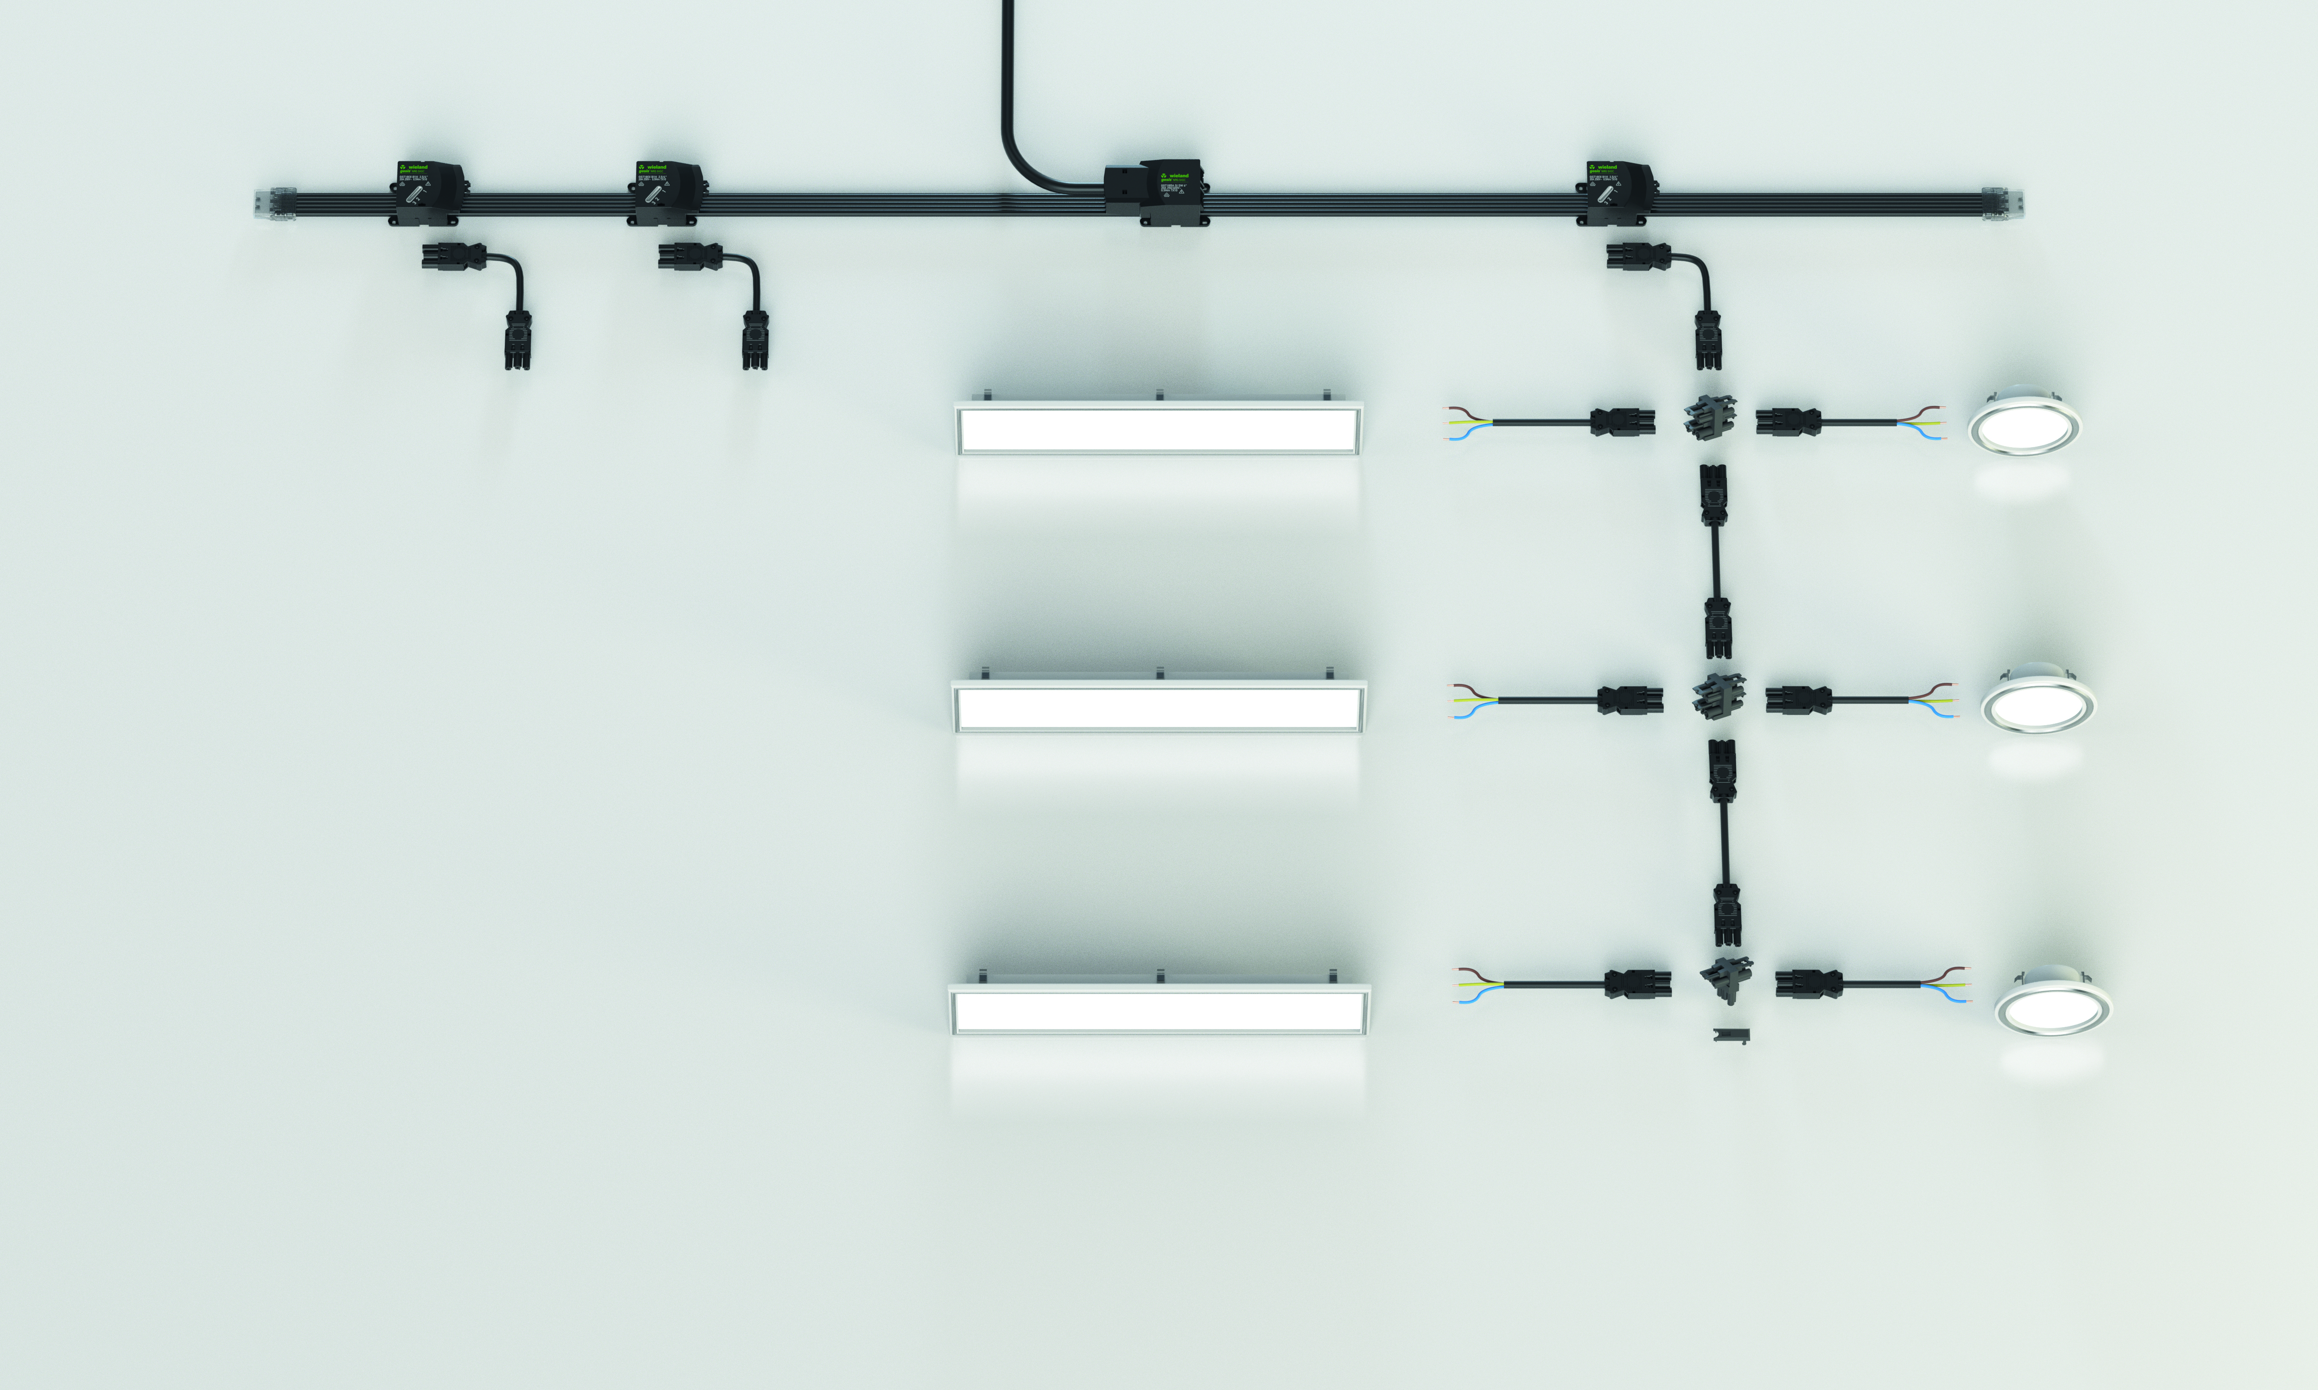
Application example 1/3 lighting

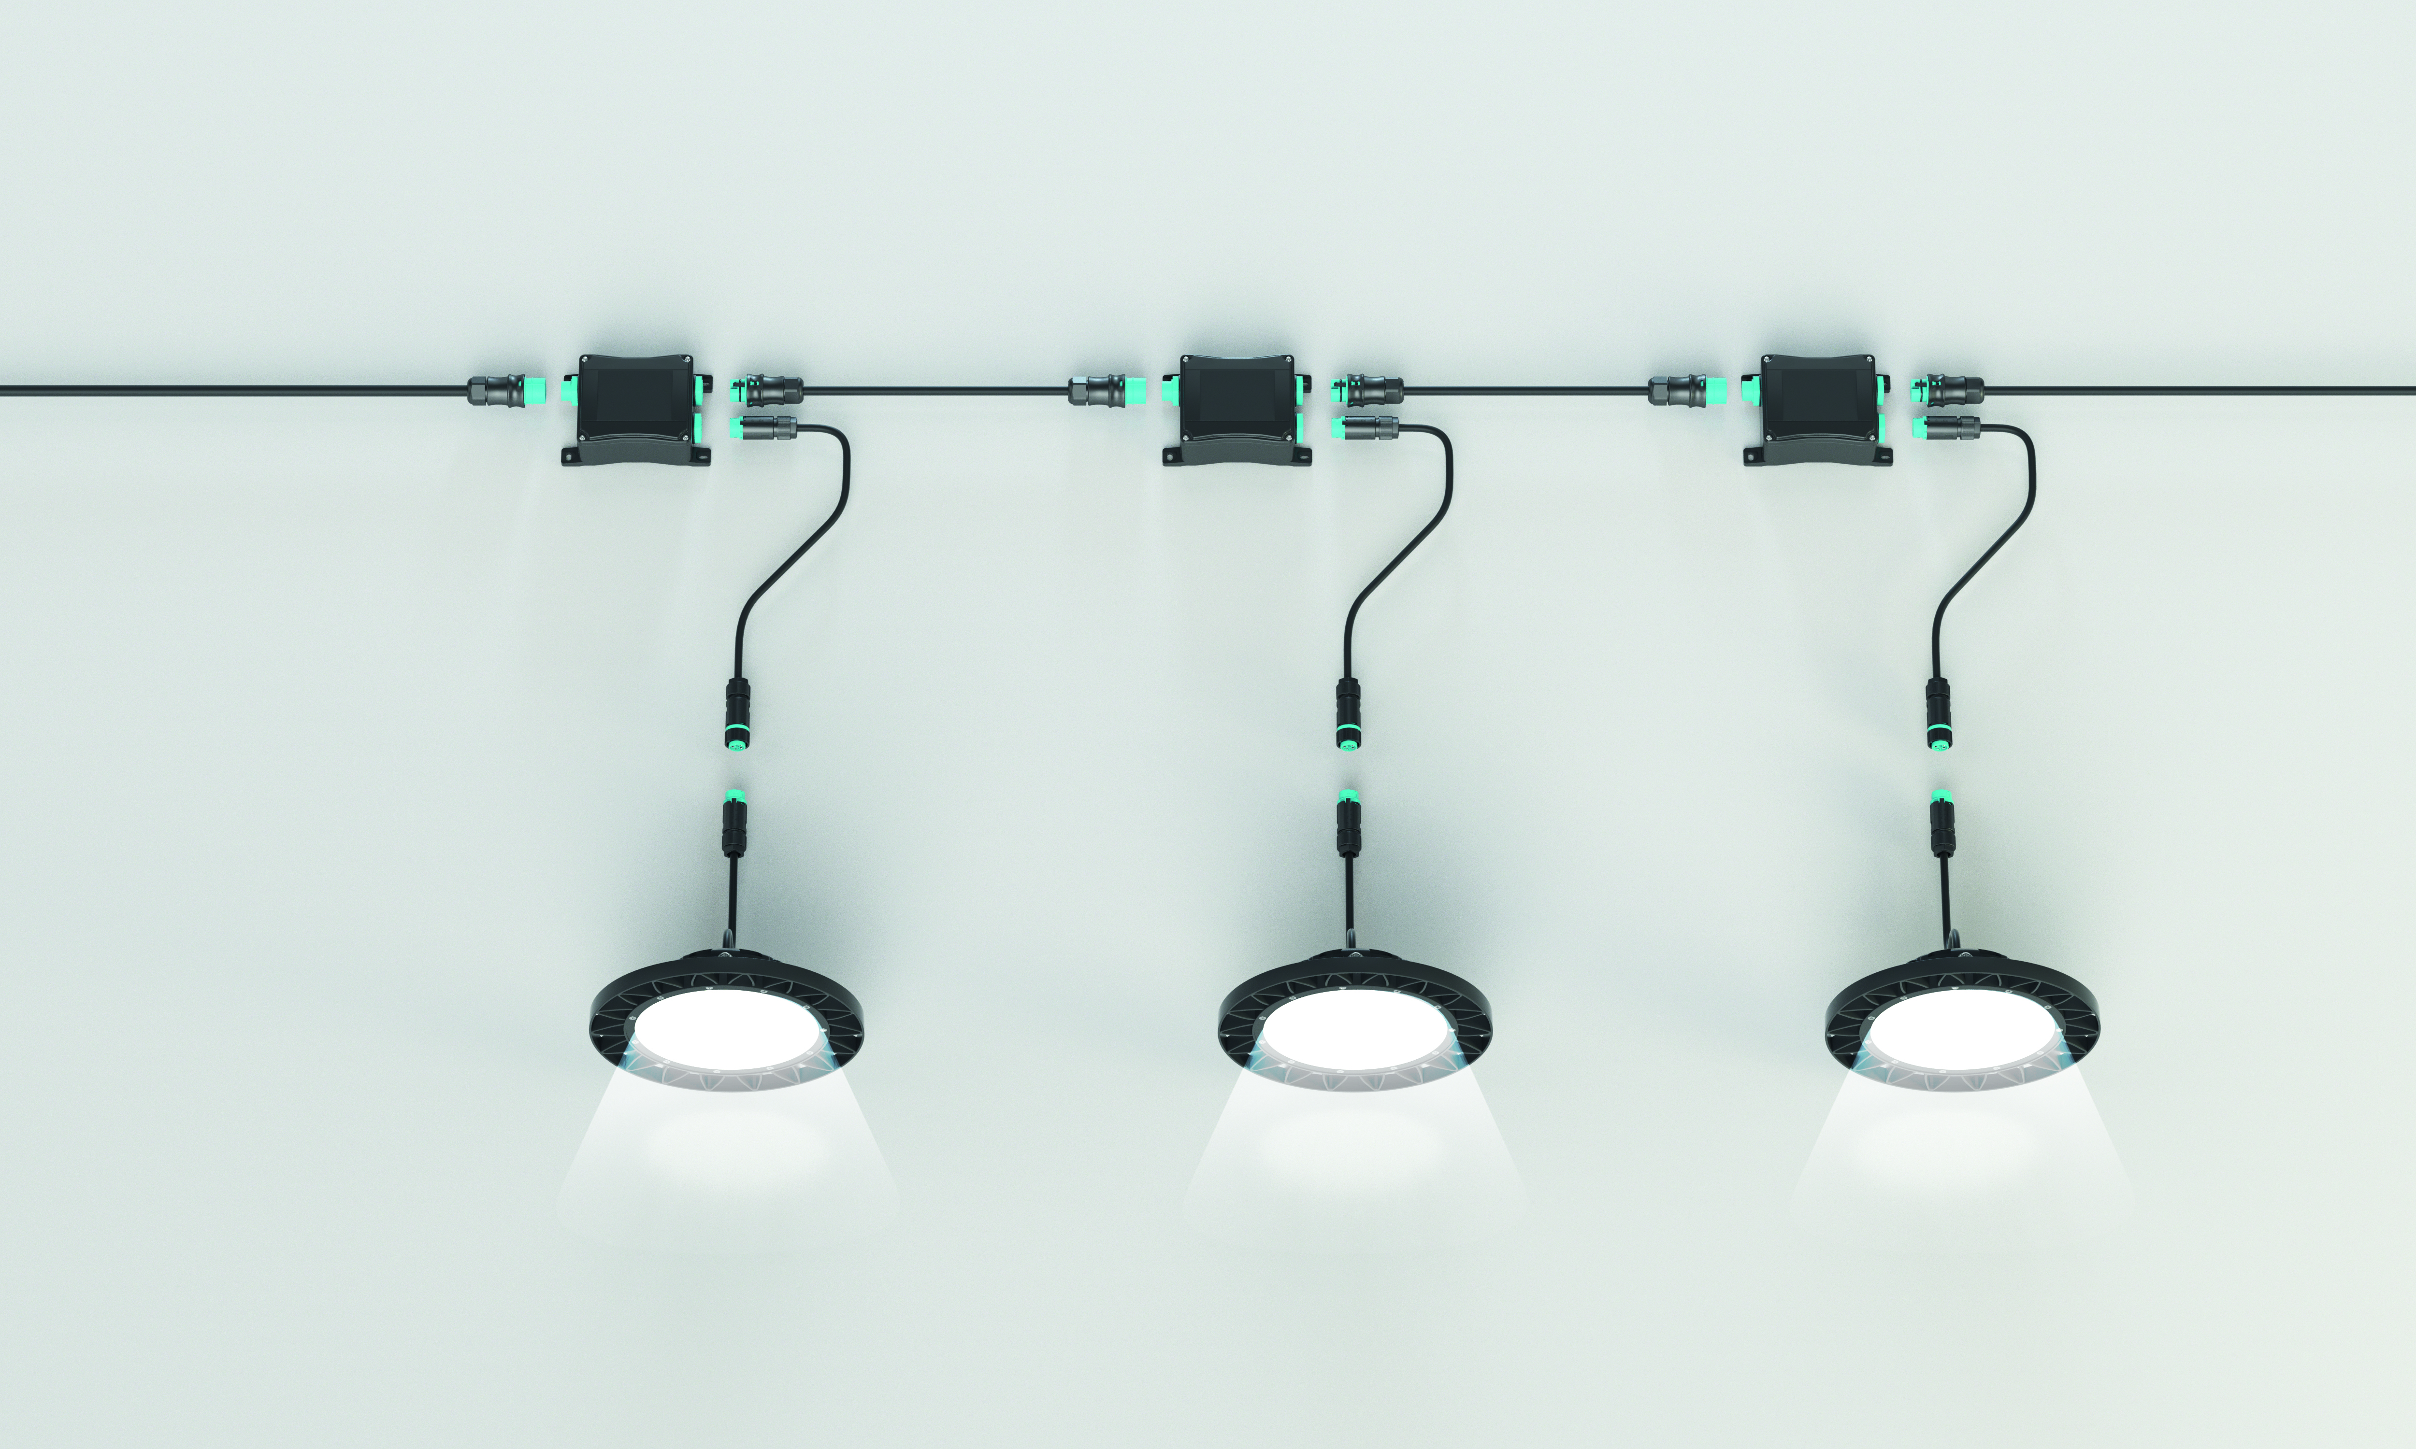
Application example dimmable lighting

ABOUT WIELAND ELECTRIC

Wieland Electric, founded in Bamberg in 1910, is the inventor of safe electrical connection technology. Today, the family-owned company is one of the leading suppliers of safety and automation technology and has been the global market leader in the field of pluggable electrical installations for building technology for over 30 years.

Wieland Electric assists customers with on-site support all over the world as a capable service partner and solution provider. This is possible thanks to around 1,600 employees and subsidiaries as well as sales organizations in over 70 countries. In addition to Wieland Electric GmbH, STOCKO Contact GmbH & Co. KG has belonged to Wieland Holding since 1998.

The core industries of the company are machine building, wind power, and building and lighting technology. The broad portfolio includes components, products, and solutions for electrical installation, connection technology, power distribution, safety technology, and the control cabinet. In addition, Wieland Electric offers an extensive service and training program. With cross-industry experience, great product diversity, and numerous service offerings, the company has consistently developed from a component supplier into a solution provider in recent years.

PRESS CONTACT
WIELAND ELECTRIC GMBH Sabine Eyler
Marketing Communication E-Mail: info@sabine-eyler.de
Brennerstraße 10 – 14 Phone: 0049 9285 961869
96052 Bamberg · Germany
E-Mail: communications@wieland-electric.com
Internet: www.wieland-electric.de

