PRESS RELEASE

READY FOR THE REQUIREMENTS OF FUTURE-PROOF NETWORKS

Wieland Electric supports maximum flexibility and reliable industrial communication with SFP ports

Faster, more flexible, more secure - the demands on network technology in the production environment are constantly increasing. The aim is to exchange even larger volumes of data quickly and reliably at the same time. In order to offer users the greatest possible flexibility in the implementation of high-performance networks, Wieland Electric has expanded its portfolio in the area of industrial communication. SFP ports for unmanaged and managed IP switches are available here, making it possible to respond quickly and easily to changing network technology requirements while also taking advantage of the benefits of fiber optic technology.

Depending on the requirements and the type of SFP module used, the SFP ports can be used to increase the number of conventional RJ45 copper-bound connections via CAT5/6/7 cable or to connect a single/multimode fiber optic cable. This means that the network technology can be designed in a highly flexible manner, for example by integrating additional network subscribers or increasing the transmission speed. This is where fiber optic technology in particular comes into its own: It makes it possible to transmit large volumes of data reliably even over long distances. In addition, because Wieland Electric's SFP ports are hot-pluggable, they can be plugged in during operation, making the switch easily adaptable. Troubleshooting is also made easier because the SFP modules can be replaced effortlessly.

As part of its portfolio expansion in the area of industrial communication, Wieland Electric enables the greatest possible flexibility in the implementation of high-performance network technology with the SFP modules

IMAGE MATERIAL
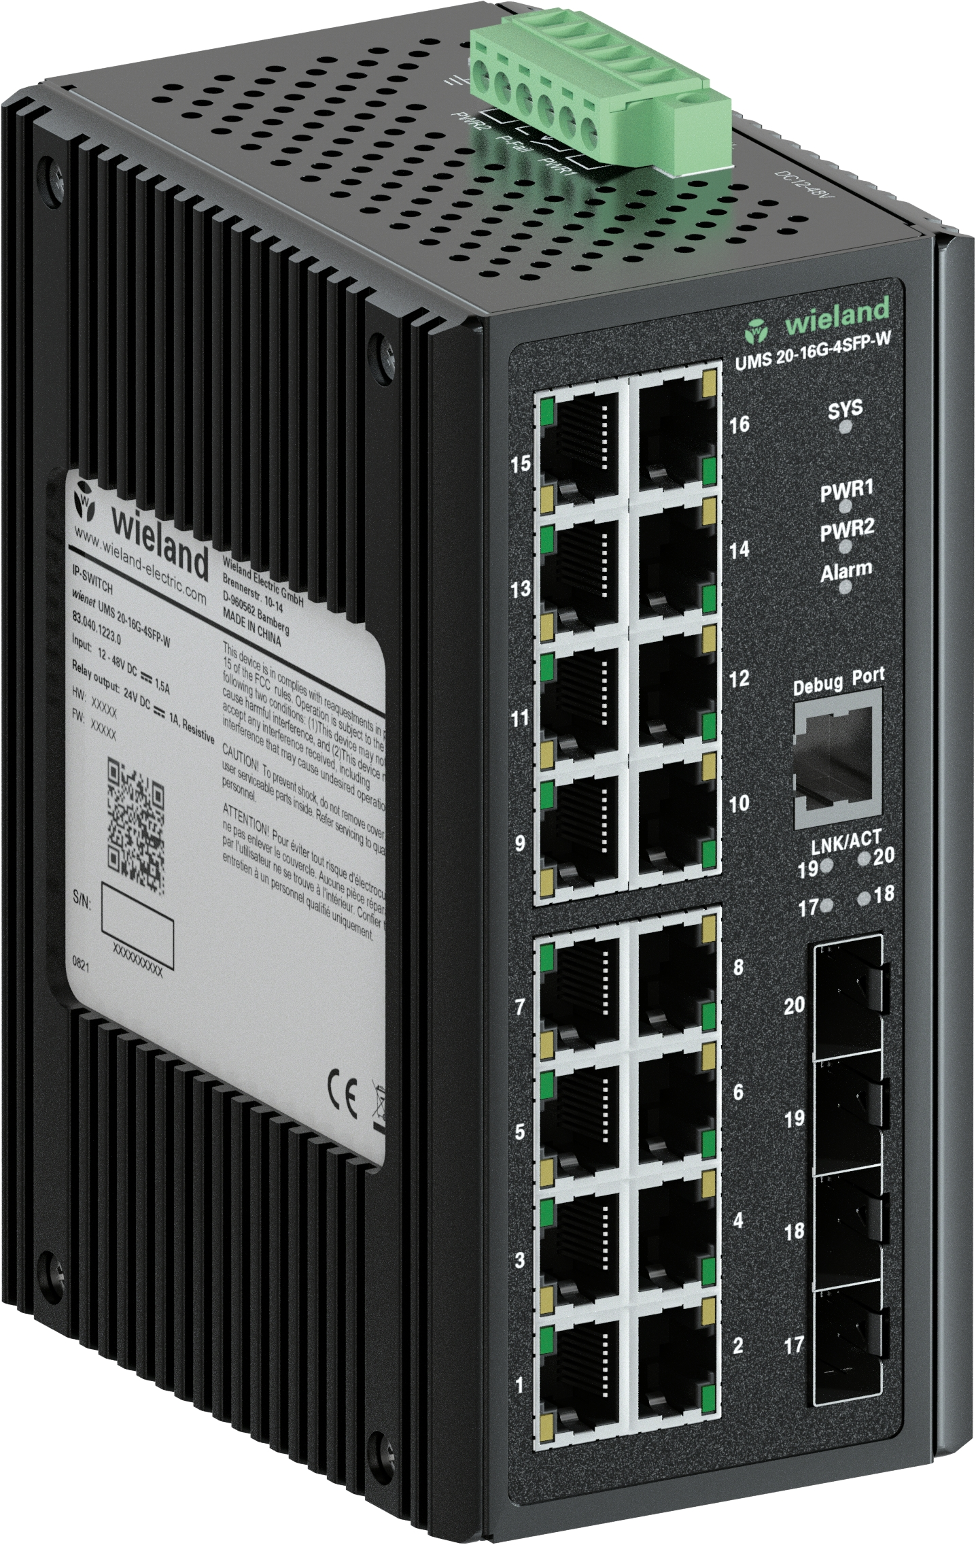

Product overview

IP switch WIENET UMS 20-16G-4SFP-W (part number 83.040.1223.0)
Unmanaged switch with 16 Gigabit Ethernet (10/100/1000 Mbps) and 4 SFP ports, extended temperature range
IP switch WIENET UMS 6-C-1G-4PoEP-1SFP-W (part number 83.040.1268.0)
Unmanaged switch with 1 Gigabit Ethernet (10/100/1000 Mbit/s), 4 Power over Ethernet and 1 SFP port, slim design, extended temperature range
IP switch WIENET UMS 5-C-4G-1SFP-W (part number 83.040.1256.0)
Unmanaged switch with 4 Gigabit (10/100/1000 Mbit/s) and 1 SFP port, slim design, extended temperature range

ABOUT WIELAND ELECTRIC

Wieland Electric, founded in Bamberg in 1910, is the inventor of safe electrical connection technology. Today, the family-owned company is one of the leading suppliers of safety and automation technology and has been the global market leader in the field of pluggable electrical installations for building technology for over 30 years.

Wieland Electric assists customers with on-site support all over the world as a capable service partner and solution provider. This is possible thanks to around 1,600 employees and subsidiaries as well as sales organizations in over 70 countries. In addition to Wieland Electric GmbH, STOCKO Contact GmbH & Co. KG has belonged to Wieland Holding since 1998.

The company’s core industries are mechanical engineering, wind power, intralogistics, HVAC and
building and lighting technology. The broad portfolio includes components, products and solutions for electrical installation, connection technology, power distribution, safety technology and the control cabinet. In addition, Wieland Electric offers an extensive service and training program. With cross-industry experience, a great product diversity and numerous service offerings, the company has consistently developed from a component supplier to a solution provider in recent years.

YOUR PRESS CONTACT

WIELAND ELECTRIC GMBH
Alexander Viertmann / Marketing Communication
Phone: +49 951 9324 316
E-mail: communications@wieland-electric.com
Internet: www.wieland-electric.de

