HANNOVER MESSE 2019 PRESS RELEASE

NEW MODELS FOR RELIABLE ANALOG VALUE PROCESSING

WIELAND ADDS THREE NEW INPUT MODULES FOR ANALOG SIGNALS TO SAMOS® PRO COMPACT SAFETY CONTROLLER

In many applications it is essential that analog variables such as pressure, flow, and temperature are monitored in order to ensure safe automation, so Wieland Electric has now extended the portfolio for its samos® PRO COMPACT safety controller. With three new input modules, namely SP-SAC, SP-SAR4, and SP-SACR22, it is now possible to reliably detect and further process analog signals as well. These modules are ideal for use in process engineering applications in the glass, metal, or chemical industry or also in specific areas of mechanical engineering such as conveyor systems, presses, and CNC machines

The new modules support sensors with a 0/4-20mA interface as well as temperature-dependent resistors like Pt/Ni sensors and deliver their analog data to the samos® PRO COMPACT safety controller. The analog values can be monitored with the new and reliable “Limit”, “Range”, “Relation”, and “Difference” function blocks in user programs created with the license-free programming software samos® PLAN 6. These efficient function blocks enable comparative or arithmetic operations involving analog data as well as scaling of the measured current values, and the presentation and visualization of the analog values in samos® PLAN 6.

Integrated USB and ETH interfaces enable access to the system at any time. Industrial Ethernet protocols have been included from the outset, and further additional gateways for fieldbuses will make any necessary integration into a wide variety of industrial networks incredibly simple. This ensures greater transparency for the user as the analog values too can easily be transferred to other control systems. Up to three different fieldbus systems can be operated from one samos® PRO COMPACT in parallel.

For safe operation of the system, all inputs and outputs have uniquely assigned visual displays that clearly show the operating status at any time. The samos® PLAN 6 software provides a customized report, ensuring that the plant’s documentation complies with all applicable regulations. It goes without saying that the modules meet all safety standards, including SIL CL 3 according to EN 62061 and PL e / category 4 according to EN ISO 13849-1.

As a special feature for combustion plants like thermoprocessing plants and steam boiler systems, the entire samos® PRO COMPACT family is also approved according to EN746-2 and EN50156-1.

IMAGE MATERIAL

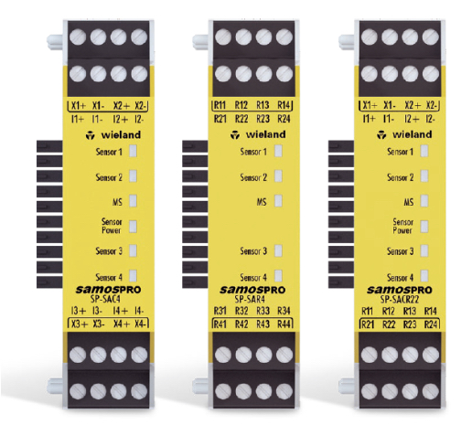

By adding three new input modules to its samos PRO safety controller, Wieland has now made it possible to process analog values reliably.

PRESS DOWNLOAD SECTION
This press release can be downloaded from our website:
http://wie.li/pressehmi19

ABOUT WIELAND ELECTRIC

Wieland Electric, founded in Bamberg in 1910, is the inventor of safe electrical connection technology. Today, the family-owned company is one of the leading suppliers of safety and automation technology and has been the global market leader in the field of pluggable electrical installations for building technology for over 30 years.

Wieland Electric assists customers with on-site support all over the world as a capable service partner and solution provider. This is possible thanks to around 1,600 employees and subsidiaries as well as sales organizations in over 70 countries. In addition to Wieland Electric GmbH, STOCKO Contact GmbH & Co. KG has belonged to Wieland Holding since 1998.

The core industries of the company are mechanical engineering, wind power, and building and lighting technology. The broad portfolio includes components, products, and solutions for electrical installation, connection technology, power distribution, safety technology, and the control cabinet. In addition, Wieland Electric offers an extensive service and training program. With cross-industry experience, great product diversity, and numerous service offerings, the company has consistently developed from a component supplier into a solution provider in recent years.

YOUR PRESS CONTACT

WIELAND ELECTRIC GMBH
Marketing Communication
Brennerstraße 10 – 14
96052 Bamberg · Germany

E-mail: communications@wieland-electric.com
Internet: www.wieland-electric.com

