PRESS RELEASE

Permanent further development: Ultra-small connector for lighting and industrial applications expanded to include distributors

With the RST® Micro, Wieland Electric presents a miniature connector that, with its diameter of less than 15 mm, meets the highest requirements for design and flexibility. The plug is in demand wherever technology is becoming smaller and smaller, and electrical connections must therefore also become smaller and smaller. Now the system also includes a distributor option

Miniature connector for extra-low-voltage and network applications
Bamberg-based Wieland Electric presents the RST® Micro, a miniature connector designed specifically for low-voltage applications. The 2 to 3 pole connector with a diameter of less than 15 mm is optimized for the interface between voltage or current sources and LED modules. In addition, it is ideally suited for the industrial environment. Thanks to its rated values, network applications are no problem either. Four mechanically and color-coded plug connections ensure safe separation of different applications.
Particularly small and unobtrusive, easy to operate without any disruptive locking geometries, protected against any strain, and sealed, the RST Micro is a connector which, thanks to its compact design and functionality, is unique on the market.

Extension by manifold
The latest addition to the modular RST® system are the distribution blocks for the RST® Micro. Available in 1 E/ 2 A and 1 E/ 3 A (input/output) for 2 & 3 -pole. New manufacturing technologies have made it possible to reduce the size to a minimum. The distributors are available for all common codings and the internal wiring offers a serial or a parallel option. The addition of the distributors rounds off the system to a certain extent, as the distributors occupy a central position in the electrical infrastructure of the RST® system. Thus, they serve both for energy and signal distribution.

Pluggable installation saves time and money
Just like the larger members of the RST® product family, the RST® Micro miniature connector makes installation particularly easy, fast and safe. The continuous pluggable RST system - from the distributor to the electrical device - consists of factory-assembled and tested components in the guaranteed always the same design quality. This makes project and process flows easier to calculate. Assembly times can be reduced by up to 70 percent compared to conventional installation. Total costs are reduced by 30 percent. The flexible plug-in system also helps with conversions or extensions, as installation is quickly and easily adapted. Defective devices are replaced in no time at all.

Technical data
Rated voltage: ~50/-120V; 250V; 250/400V
Rated current: 8A
Protection rating: IP66/68/69 + optional water-stop feature
(3,256 incl. spaces)

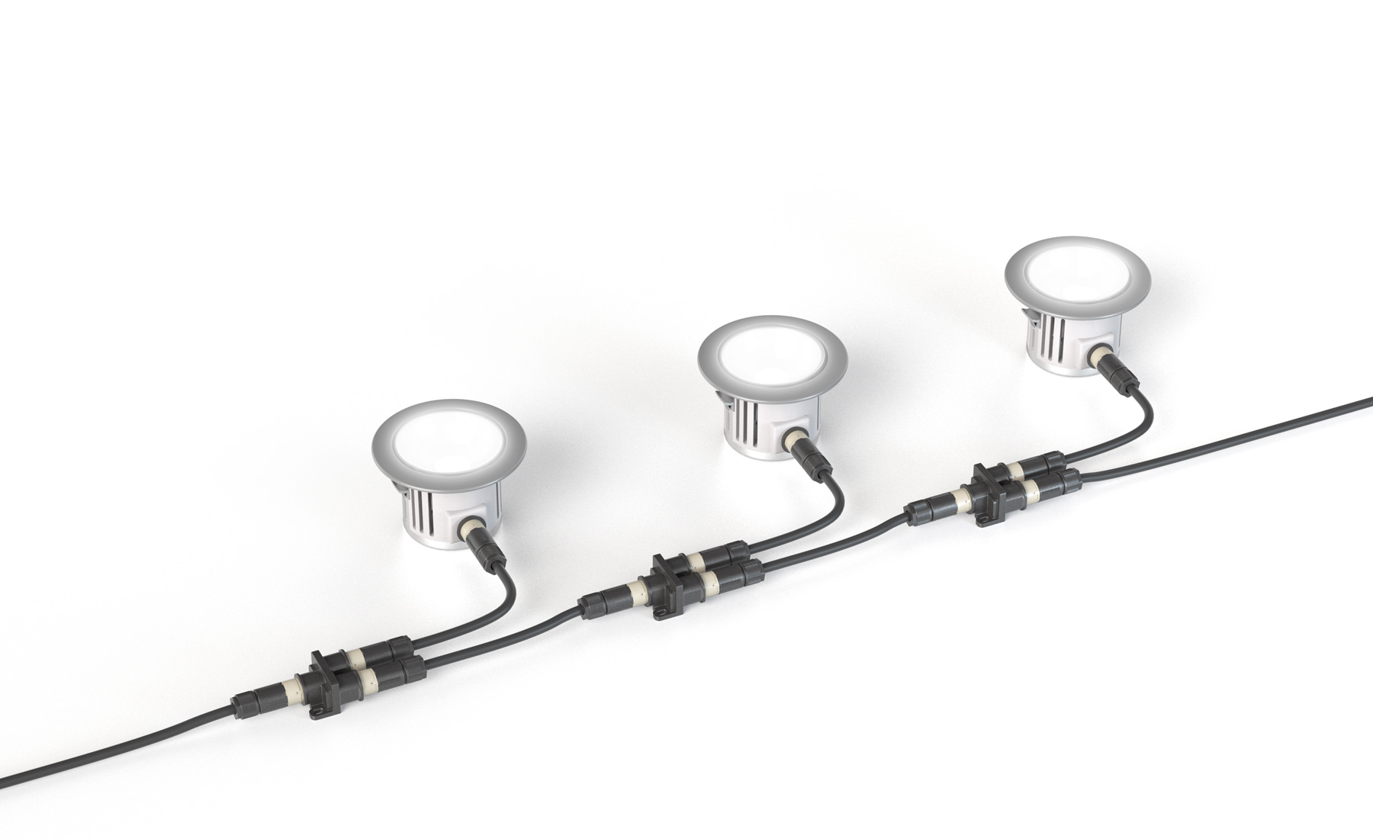
Distributor, serial

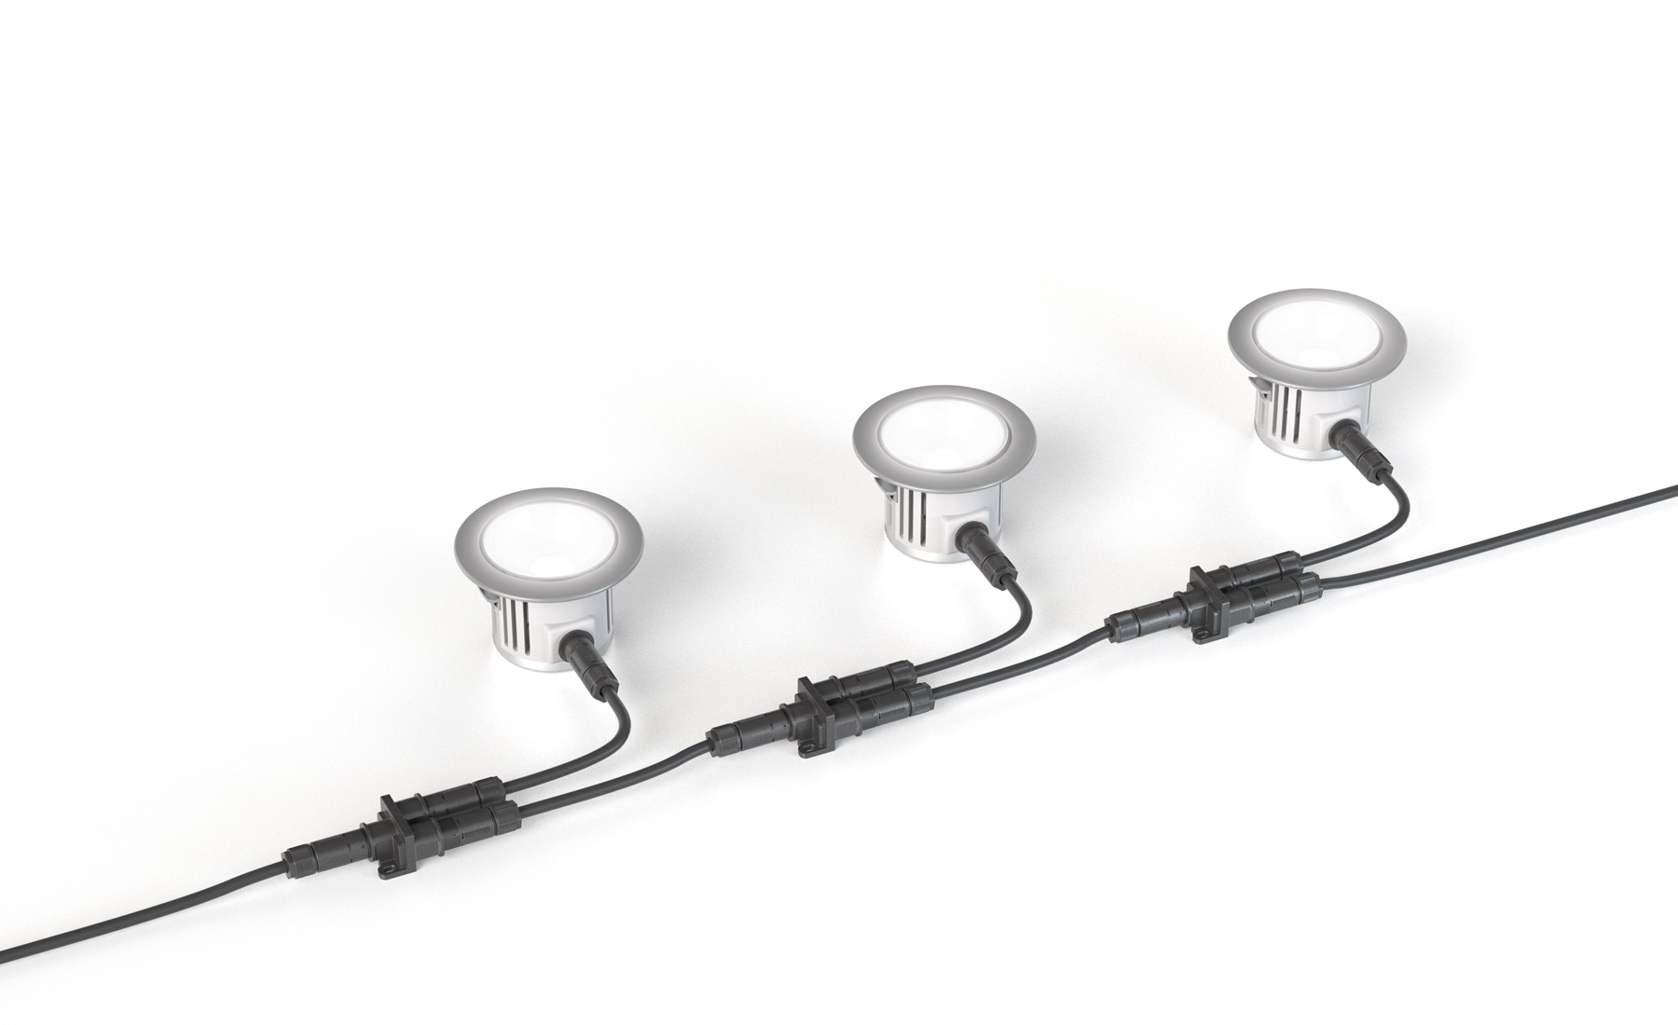
Distributor, parallel

ABOUT WIELAND ELECTRIC

Wieland Electric, founded in Bamberg in 1910, is the inventor of safe electrical connection technology. Today, the family-owned company is one of the leading suppliers of safety and automation technology and has been the global market leader in the field of pluggable electrical installations for building technology for over 30 years.

Wieland Electric assists customers with on-site support all over the world as a capable service partner and solution provider. This is possible thanks to around 1,600 employees and subsidiaries as well as sales organizations in over 70 countries. In addition to Wieland Electric GmbH, STOCKO Contact GmbH & Co. KG has belonged to Wieland Holding since 1998.

The company's core industries include mechanical engineering, wind power, intralogistics and HVAC, as well as
building and lighting technology. The broad portfolio includes components, products and solutions for electrical installation, connection technology, power distribution, safety technology and the control cabinet. In addition, Wieland Electric offers an extensive service and training program. With cross-industry experience, a great product diversity and numerous service offerings, the company has consistently developed from a component supplier to a solution provider in recent years.

PRESS CONTACT

WIELAND ELECTRIC GMBH
Alexander Viertmann
Marketing Communication
Brennerstrasse 10 – 14
96052 Bamberg · Germany

E-mail: communications@wieland-electric.com
Internet: www.wieland-electric.de

