Wieland Electric sets course for the future

Bamberg-based Wieland Electric, with a legacy spanning over a century, has evolved into a global leader in electrical systems and solutions. This evolution will continue as the course has been set with some exciting new developments within the organization that will enable even greater growth in the global marketplace.

As a result, Wieland Electric, with it’s 14 subsidiaries and over 1,600 employees is excited to announce a new corporate management structure that will strengthen the organization. As of August 9th, 2019, Dieter Gleisberg as Managing Director, together with Dr. Ulrich Schaarschmidt, has been leading Wieland Electric through a transformation process designed to better capitalize on emerging business opportunities in an evolving global landscape.

Mr. Gleisberg brings with him extensive experience that includes international exposure at REHAU AG and The Arvato Group, subsidiaries of the family-run Bertelsmann Group. This proven experience serves as a great asset to Wieland as Mr. Gleisberg has the insight and strategic vision to push forward a global strategy that will enable Wieland Electric to achieve new heights into the future.

The common goal of this new partnered leadership between Mr. Gleisberg and Dr. Schaarschmidt is simple but powerful: consistently meet and exceed the requirements of the global markets for fast, flexible and safe solutions. Andreas M. Wieland, Chairman of the Shareholders’ Meeting, comments on the change and provides thanks to outgoing Managing Director Dr. Oliver Eitrich on behalf of the Shareholders’ Meeting and Advisory Board for his many years of contributions to the company: “Dr. Eitrich has left his mark on Wieland over many years. We are very grateful to him for his work and wish him all the best for the future”.

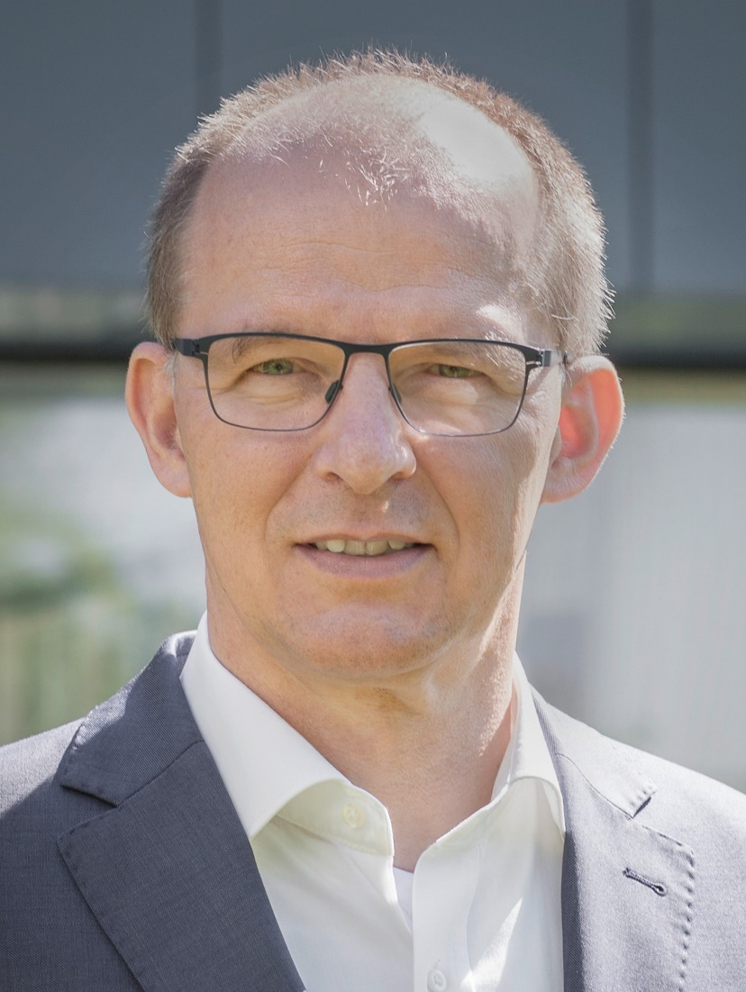

Managing Director of Wieland Electric, Dieter Gleisberg.

