PRESS INFORMATION

JANUARY 2020

Smart shelves smartly networked -
Wieland Electric shows Plug & Play solutions for shelf supply

They are intelligent and networked - the new shelves in retail. Equipped with displays, sensors and modern IoT technology, they provide the customer with plenty of service and the retailer with useful information. At the EuroShop in Düsseldorf, Wieland Electric will present how the new shelves can be supplied with energy and data in a particularly safe and flexible way.

Intelligent racking works best with intelligent connection technology. This comes from the electrical distributor to the shelf as a pluggable system from Bamberg-based manufacturer Wieland. All functional units function according to a smart plug & play principle, and are therefore easy, quick and safe to install. No matter how often a shelf is modified or repositioned, the installation is easy and can be adapted easily and without a specialist electrician thanks to its pluggability.

The system offers high flexibility in power distribution and clear structures for added safety. All areas are thus locally secured. If a fault occurs anywhere in the area, it is not the entire supply that fails, but only a small, limited section. A local surge protection can also be easily plugged in and, if necessary, reliably protects devices connected in the rack.

The distribution of the power supply to different shelves or shelf levels is done without effort via pluggable junction boxes.

Wieland at the EuroShop in Düsseldorf
You can experience these and many other tailor-made solutions from Wieland Electric for the retail trade in a very practical way at EuroShop from 16 to 20 February (Hall 9, Stand B 44) in Düsseldorf.

IMAGE MATERIAL

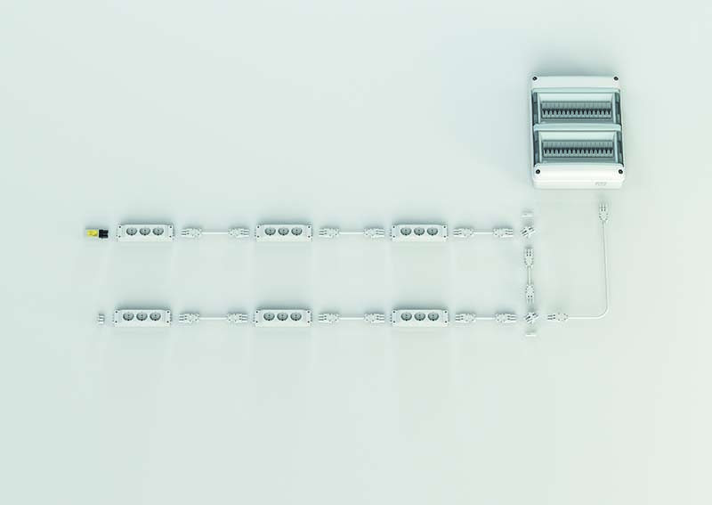
Application example shelf supply

ABOUT WIELAND ELECTRIC

Wieland Electric, founded in Bamberg in 1910, is the inventor of safe electrical connection technology. Today, the family-owned company is one of the leading suppliers of safety and automation technology and has been the global market leader in the field of pluggable electrical installations for building technology for over 30 years.

Wieland Electric assists customers with on-site support all over the world as a capable service partner and solution provider. This is possible thanks to around 1,600 employees and subsidiaries as well as sales organizations in over 70 countries. In addition to Wieland Electric GmbH, STOCKO Contact GmbH & Co. KG has belonged to Wieland Holding since 1998.

The core industries of the company are machine building, wind power, and building and lighting technology. The broad portfolio includes components, products, and solutions for electrical installation, connection technology, power distribution, safety technology, and the control cabinet. In addition, Wieland Electric offers an extensive service and training program. With cross-industry experience, great product diversity, and numerous service offerings, the company has consistently developed from a component supplier into a solution provider in recent years.

PRESS CONTACT
WIELAND ELECTRIC GMBH Sabine Eyler
Marketing Communication E-Mail: info@sabine-eyler.de
Brennerstraße 10 – 14 Phone: 0049 9285 961869
96052 Bamberg · Germany
E-Mail: communications@wieland-electric.com
Internet: www.wieland-electric.de

