JULY 2021
PRESS INFORMATION

CHANGE OF MANAGING DIRECTOR AT WIELAND ELECTRIC
BERND P. UCKROW RETIRES AND HANDS OVER THE COMMERCIAL MANAGEMENT OF THE COMPANY TO DR. CHRISTIAN WAHLERS

Bernd P. Uckrow, who previously held the commercial management position, is retiring from Wieland Electric GmbH after the regular expiration of his contract. He hands over an economically stable company, which emerged strengthened from the difficult year of Corona 2020.

In his place, Dr. Christian Wahlers will from now on lead the commercial affairs of Wieland Electric and form, together with Dr.-Ing. Börne Rensing, the new dual leadership of the management board.

Dr. Wahlers, born in 1967, studied business administration at the University of Göttingen, where he also received his PhD in 1995 from the Chair of Business Information Systems. Most recently, he was CFO (Chief Financial Officer) since 2006 for BITZER SE and KAMAX Holding GmbH & Co. KG, also medium-sized family-owned companies.
With over 25 years of professional experience in management positions, Christian Wahlers brings practical experience in the commercial environment. He chose Wieland Electric GmbH because he sees excellent future potential in Wieland's products and markets, a good starting position is available and he also sees an opportunity for himself to make a difference. Dr. Wahlers is married and has two children.

IMAGE MATERIAL

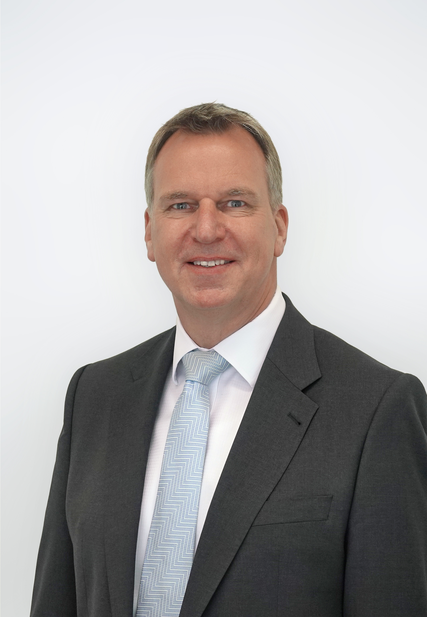

ABOUT WIELAND ELECTRIC

Wieland Electric, founded in Bamberg in 1910, is the inventor of safe electrical connection technology. Today, the family-owned company is one of the leading suppliers for safety and automation technology and has been the world market leader in the field of pluggable electrical installation for building technology for over 30 years.

Wieland Electric supports customers worldwide on site as a competent service partner and solution provider. This is possible with around 1,600 employees and subsidiaries as well as sales organizations in over 70 countries. In addition to Wieland Electric GmbH, since 1998 STOCKO Contact GmbH & Co. KG has been part of the Wieland holding company since 1998.

The company's core industries include mechanical engineering, wind power, intralogistics and HVAC as well as building and lighting technology. The broad portfolio includes components, products and solutions for electrical installation, connection technology, power distribution, safety technology and the control cabinet. In addition, Wieland Electric offers an extensive service and training program. With cross-industry experience, a wide range of products and numerous service offerings, the company has consistently developed from a component provider to a solution provider in recent years

PRESS CONTACT
WIELAND ELECTRIC GMBH
Alexander Viertmann / Marketing Communication
Telefon: +49 951 9324 316
E-Mail: communications@wieland-electric.com
Internet: www.wieland-electric.com

