FEBRUARY 2023 PRESS INFORMATION

WITH WIELAND PLUG TO THE SAFE BALCONY POWER PLANT

^{RST®} SYSTEM SOCKET FROM WIELAND ELECTRIC ENABLES STANDARD-COMPLIANT INSTALLATION OF MINI SOLAR SYSTEMS

Making a contribution to the energy revolution without having to make major structural changes - that's exactly what balcony power plants do. The compact and therefore very handy photovoltaic systems are becoming increasingly popular, as they can be easily installed on the balcony of a house and connected to the house's power grid. However, a standard-compliant installation plays a decisive role in the safe operation of mini solar systems. For this purpose, Wieland Electric offers a suitable connection solution with its RST® ^{system}socket, which is based on the currently valid VDE standards and thus offers a high degree of safety.

"As tempting as self-assembly is - if you want to turn your own balcony into a safe source of energy, you should usea power feed socket that complies with the requirements of DIN VDE V 0100-551-1 and is installed by trained electricians," explains Wolfram Hohmann, product manager for connection technology at Wieland Electric. "Our compact RST® ^{system} socket meets these requirements and, thanks to plug & play functionality, comes with various advantages for easy and safe handling. These include a mechanical interlock that prevents unintentional disconnection, as well as contact-protected contacts of the plug part, which provides protection against electric shock even when unplugged in the event of a possible fault."

For a flush-mounted installation, a mounting frame is available, which is to be mounted in a commercially available flush-mounted box with a depth of at least 60 mm. Alternatively, the mounting frame is installed in the surface-mounted housing.

IMAGE MATERIAL

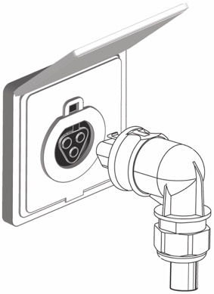

Using the RST® system socket from Wieland Electric, balcony power plants can be installed in compliance with standards and operated safely. (Image: Wieland Electric)

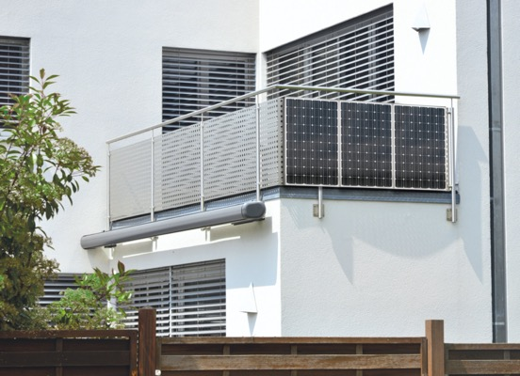

Balcony power plants offer consumers the opportunity to contribute to the energy transition without having to make major structural changes. (Photo: Hermann - stock.adobe.com)

PRESS CONTACT
Anna Lena Held
Campaign Management
Phone: +49 951 9324106
Email: AnnaLena.Held@wieland-electric.com

Marion Nikol
COMMUNICATION FOR INDUSTRY & TECHNOLOGY
Phone: +49 170 2731025
E-mail: info@intecsting.de

ABOUT WIELAND ELECTRIC

Wieland Electric, founded in Bamberg in 1910, is the inventor of safe electrical connection technology. Today, the family-owned company is one of the leading suppliers of safety and automation technology and has been the global market leader in the field of pluggable electrical installations for building technology for over 30 years.

Wieland Electric assists customers with on-site support all over the world as a capable service partner and solution provider. This is possible thanks to around 1,600 employees and subsidiaries as well as sales organizations in over 70 countries. In addition to Wieland Electric GmbH, STOCKO Contact GmbH & Co. KG has belonged to Wieland Holding since 1998.

The company's core industries include mechanical engineering, wind power, intralogistics and HVAC, as well as building and lighting technology. The broad portfolio includes components, products, and solutions for electrical installation, connection technology, power distribution, safety technology, and the control cabinet. In addition, Wieland Electric offers an extensive service and training program. With cross-industry experience, a great product diversity and numerous service offerings, the company has consistently developed from a component supplier to a solution provider in recent years.

