PRESS INFORMATION

JANUARY 2020

No more chaos at the cash register desk
Wieland Electric: Intelligent, pluggable solutions for cash register supply

Friday night. The place is packed. One shopping cart follows another. Suddenly, the checkouts are down. It's a nightmare for retailers and customers. No more scanning, no more weighing, no more paying. At the EuroShop in Düsseldorf, Wieland Electric will be demonstrating how modern POS systems can be supplied safely and reliably with power and data and how such failures can be prevented.

The manufacturer from Bamberg relies on a clear structure for the supply of POS systems through modular installation and defined structures. The installation is structured and plannable primarily because all components from the transfer distributor in the ceiling area to the consumers in the cash desk are designed to be pluggable. This facilitates maintenance and repair. Defective parts can be replaced quickly and easily without risk of paralysing the entire system. Subsequent adaptations and extensions are also possible at any time, easily and without problems.

Infrastructure cabling, system and socket distributors form a well thought-out and secure system. Power distribution and protection is modular and decentralized by system distributors on the cable route. These are supplied via flexible flat cables with AV and UPS network and all necessary data lines. The connection from the ceiling to the cash desk is made with connecting cables and patch cables. In turn, a system distributor with sufficient sockets and data connections is installed in each cash desk, which in turn guarantee maximum flexibility and order in the supply of all consumers in the cash desk.

When modernizing cash register systems, no intervention in the infrastructure is necessary. The new systems are simply plugged into the existing infrastructure cabling, which considerably reduces the effort and installation time.

Wieland at the EuroShop in Düsseldorf

You can experience these and many other tailor-made solutions from Wieland Electric for the retail trade in a very practical way at EuroShop from 16 to 20 February (Hall 9, Stand B 44) in Düsseldorf.

PICTURE MATERIAL

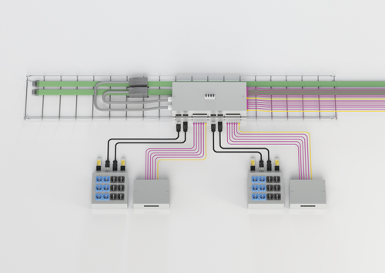
Application example cash desk supply

ABOUT WIELAND ELECTRIC

Wieland Electric, founded in Bamberg in 1910, is the inventor of safe electrical connection technology. Today, the family-owned company is one of the leading suppliers of safety and automation technology and has been the global market leader in the field of pluggable electrical installations for building technology for over 30 years.

Wieland Electric assists customers with on-site support all over the world as a capable service partner and solution provider. This is possible thanks to around 1,600 employees and subsidiaries as well as sales organizations in over 70 countries. In addition to Wieland Electric GmbH, STOCKO Contact GmbH & Co. KG has belonged to Wieland Holding since 1998.

The core industries of the company are machine building, wind power, and building and lighting technology. The broad portfolio includes components, products, and solutions for electrical installation, connection technology, power distribution, safety technology, and the control cabinet. In addition, Wieland Electric offers an extensive service and training program. With cross-industry experience, great product diversity, and numerous service offerings, the company has consistently developed from a component supplier into a solution provider in recent years.

PRESS CONTACT
WIELAND ELECTRIC GMBH Sabine Eyler
Marketing Communication E-Mail: info@sabine-eyler.de
Brennerstraße 10 – 14 Phone: 0049 9285 961869
96052 Bamberg · Germany
E-Mail: communications@wieland-electric.com
Internet: www.wieland-electric.de

