HANNOVER MESSE 2019 PRESS RELEASE

WIELAND PRESENTS DECENTRALIZED PODIS PSU

QUICK INSTALLATION AND MAXIMUM FLEXIBILITY IN ENERGY DISTRIBUTION

For Hannover Messe 2019, Wieland Electric is extending its energy distribution portfolio with the podis PSU, a new power supply unit for decentralized generation and distribution of DC 24-volt power. With decentralized installation solutions, machines and plants can be adapted to changing needs with ease and flexibility. Users also profit from fast installation. The power supply unit is ideal for large and widely networked machines in conveyor systems and logistics.

Modularization, data communication, and flexibility for modification – sophisticated solutions are required to meet the requirements of these trends in mechanical engineering and plant construction. Wieland is responding to this need with the new podis PSU, which converts 230 V into 24 V DC. The extra-low voltage can be distributed easily via the flat cable of the podis energy bus system so that the 24V power can be tapped where it is needed. With large installations in particular, the decentralized solution means that long distances between the power supply unit and the consumer, and therefore large cable cross-sections, can be avoided, which in turn saves costs. The 600-watt power supply unit offers an output of up to 25 A and boasts an adjustable output voltage of 24 to 30 V DC. It is equipped with pluggable inputs and outputs for the RST 20i3 round connector and can easily be integrated into existing plant structures.

(1,586 incl. spaces)

IMAGE MATERIAL

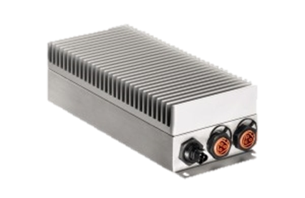
With the new podis PSU, Wieland enables decentralized generation and distribution of DC 24-volt power.

PRESS DOWNLOAD SECTION
This press release can be downloaded from our website:
http://wie.li/pressehmi19

ABOUT WIELAND ELECTRIC

Wieland Electric, founded in Bamberg in 1910, is the inventor of safe electrical connection technology. Today, the family-owned company is one of the leading suppliers of safety and automation technology and has been the global market leader in the field of pluggable electrical installations for building technology for over 30 years.

Wieland Electric assists customers with on-site support all over the world as a capable service partner and solution provider. This is possible thanks to around 1,600 employees and subsidiaries as well as sales organizations in over 70 countries. In addition to Wieland Electric GmbH, STOCKO Contact GmbH & Co. KG has belonged to Wieland Holding since 1998.

The core industries of the company are mechanical engineering, wind power, and building and lighting technology. The broad portfolio includes components, products, and solutions for electrical installation, connection technology, power distribution, safety technology, and the control cabinet. In addition, Wieland Electric offers an extensive service and training program. With cross-industry experience, great product diversity, and numerous service offerings, the company has consistently developed from a component supplier into a solution provider in recent years.

YOUR PRESS CONTACT

WIELAND ELECTRIC GMBH
Marketing Communication
Brennerstraße 10 – 14
96052 Bamberg · Germany

E-mail: communications@wieland-electric.com
Internet: www.wieland-electric.com

