PRESS RELEASE

A NEW DIMENSION OF COMPACT IP SWITCHES

Wieland Electric expands its portfolio of unmanaged switches with extremely compact variants featuring sophisticated heat management

It is a trend that is being reinforced by the current shortage of materials for metals: Plants and machines are becoming more and more compact. This also affects control cabinets close to the machine. To meet the associated requirements and the increasing demand for space-saving components, Wieland Electric has expanded its portfolio of unmanaged switches. A total of seven new wienet IP switches are available, which are characterized by an extremely compact design. At the same time, no compromises in performance have to be accepted: Sophisticated thermal management at device level enables optimum heat dissipation, ensuring reliable operation of the devices.

The new switch variants from Wieland Electric sometimes achieve widths of just 23 mm and depths of only 72 mm. How significant the achieved space savings are can be seen in comparison with the predecessor model of the wienet UMS 5-port Gigabit switch: The installation depth and the width of the new device have been reduced by 20 and 22 percent, respectively, and the total weight by more than 73 percent. Wieland Electric is thus taking into account the development towards miniaturized control cabinets and the increased requirements in control cabinet construction. This also applies to ensuring maximum availability. Here, heat management of the electronic components plays an important role, since overheating of the devices must be avoided due to the high packing density. This has also been taken into account in the new versions of Wieland Electric's unmanaged switches in the course of well thought-out heat management.

With the new variants of its wienet unmanaged IP switches, Wieland Electric has extremely compact network components for the control cabinet ready, which are characterized by high availability thanks to their advanced heat management.

IMAGE MATERIAL

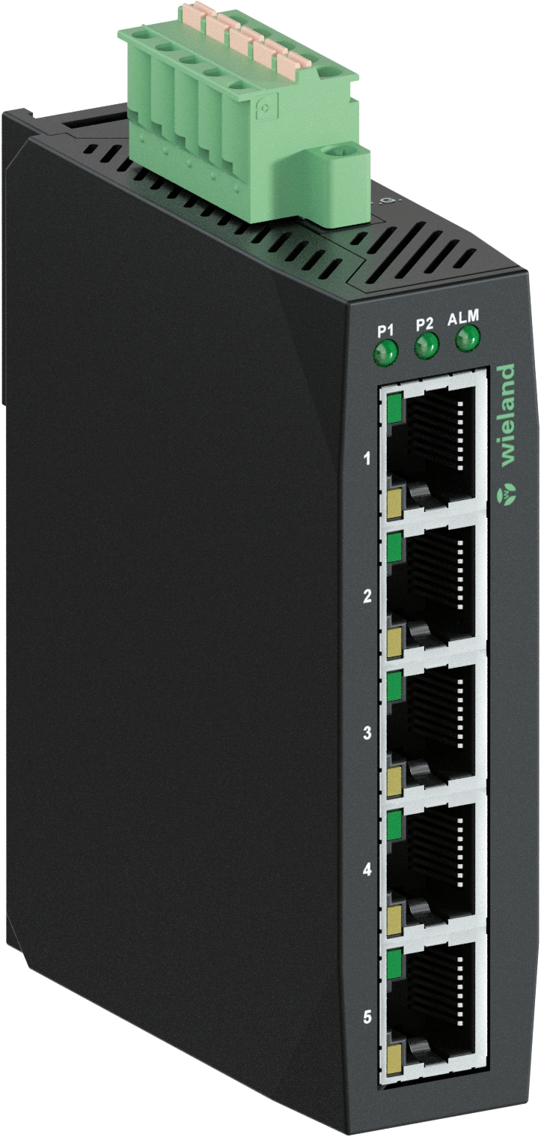

Product overview of the new versions:

IP-SWITCH WIENET UMS 5-L
Unmanaged switch with 5 Fast Ethernet (10/100 Mbit/s) ports, slim design, plastic housing

IP-SWITCH WIENET UMS 5G-L
Unmanaged switch with 5 Gigabit Ethernet (10/100/1000 Mbit/s) ports, slim design, plastic housing

IP-SWITCH WIENET UMS 4-C-2SC-FM
Unmanaged switch with 1 Fast Ethernet (10/100 Mbit/s), 2 SC and 1 multimode port, slim design

IP-SWITCH WIENET UMS 5-C-4G-1SFP-W Unmanaged switch with 4 Gigabit (10/100/1000 Mbit/s) and 1 SFP port, slim design, extended temperature range

IP-SWITCH WIENET UMS 6-C-1G-4POEP-1SFP-W
Unmanaged switch with 1 Gigabit Ethernet (10/100/1000 Mbit/s), 4 Power over Ethernet and 1 SFP port, slim design, extended temperature range

IP-SWITCH WIENET UMS 8-C
Unmanaged switch with 8 Fast Ethernet (10/100 Mbit/s) ports, slim design

IP-SWITCH WIENET UMS 8G-C
Unmanaged switch with 8 Gigabit Ethernet (10/100/1000 Mbit/s) ports, slim design

ABOUT WIELAND ELECTRIC

Wieland Electric, founded in Bamberg in 1910, is the inventor of safe electrical connection technology. Today, the family-owned company is one of the leading suppliers of safety and automation technology and has been the global market leader in the field of pluggable electrical installations for building technology for over 30 years.

Wieland Electric assists customers with on-site support all over the world as a capable service partner and solution provider. This is possible thanks to around 1,600 employees and subsidiaries as well as sales organizations in over 70 countries. In addition to Wieland Electric GmbH, STOCKO Contact GmbH & Co. KG has belonged to Wieland Holding since 1998.

The company’s core industries are mechanical engineering, wind power, intralogistics, HVAC and
building and lighting technology. The broad portfolio includes components, products and solutions for electrical installation, connection technology, power distribution, safety technology and the control cabinet. In addition, Wieland Electric offers an extensive service and training program. With cross-industry experience, a great product diversity and numerous service offerings, the company has consistently developed from a component supplier to a solution provider in recent years.

PRESS CONTACT

WIELAND ELECTRIC GMBH
Alexander Viertmann / Marketing Communication
Phone: +49 951 9324 316
E-mail: communications@wieland-electric.com
Internet: www.wieland-electric.de

