HANNOVER MESSE 2019 PRESS RELEASE

NEW MODULAR CONNECTOR SYSTEM FROM WIELAND ELECTRIC

VERSATILE REVOS MODULAR SYSTEM IS COMPATIBLE WITH THE MARKET STANDARD

At Hannover Messe 2019, Wieland Electric will be presenting revos Modular, a new, modular connector system which is compatible with the market standard and enables the transmission of energy, signals, and data in just one connector. This allows customer requirements to be met individually and flexibly. The modules can be assembled and disassembled easily without the use of tools, thereby supporting quick and error-free commissioning as well as simple replacement of assemblies. This saves time and money. Thanks to the hybrid configuration, the system can be used in a wide variety of applications, including plant construction and mechanical engineering, control cabinet construction, and also in energy generation plants.

Machines and plants are becoming increasingly modular in their design and production. This offers numerous advantages for manufacturers and operators which can be exploited optimally through use of the right connection technology. With this in mind, Wieland Electric now provides the ideal solution in the form of its new revos Modular connector system. This system, compatible with the market standard, has been designed to allow power supply, signal, bus, and fiber optic cables to be combined in one connector. This means that connectors can be configured entirely in line with individual customer requirements to suit the application. The individual modules are easy to assemble and can be replaced separately without having to disconnect everything. Handling is also simplified as one module is always fixed in place after another. The configured module frame is installed inside the housing of the revos Basic family and, thanks to the protection rating IP 65, it secures the function modules against moisture and dust, so they are also suitable for use in harsh environments.

(1,829 incl. spaces)

IMAGE MATERIAL
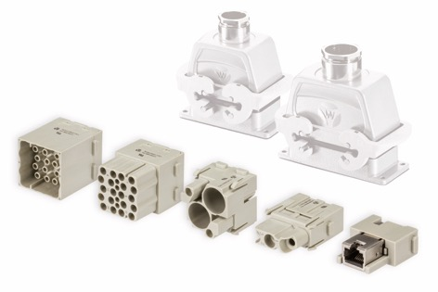

Flexible, robust, and versatile: The new, modular revos Modular connector system from Wieland is now compatible with the market standard.

PRESS DOWNLOAD SECTION
This press release can be downloaded from our website:
http://wie.li/pressehmi19

ABOUT WIELAND ELECTRIC

Wieland Electric, founded in Bamberg in 1910, is the inventor of safe electrical connection technology. Today, the family-owned company is one of the leading suppliers of safety and automation technology and has been the global market leader in the field of pluggable electrical installations for building technology for over 30 years.

Wieland Electric assists customers with on-site support all over the world as a capable service partner and solution provider. This is possible thanks to around 1,600 employees and subsidiaries as well as sales organizations in over 70 countries. In addition to Wieland Electric GmbH, STOCKO Contact GmbH & Co. KG has belonged to Wieland Holding since 1998.

The core industries of the company are mechanical engineering, wind power, and building and lighting technology. The broad portfolio includes components, products, and solutions for electrical installation, connection technology, power distribution, safety technology, and the control cabinet. In addition, Wieland Electric offers an extensive service and training program. With cross-industry experience, great product diversity, and numerous service offerings, the company has consistently developed from a component supplier into a solution provider in recent years.

YOUR PRESS CONTACT

WIELAND ELECTRIC GMBH
Marketing Communication
Brennerstraße 10 – 14
96052 Bamberg · Germany

E-mail: communications@wieland-electric.com
Internet: www.wieland-electric.com

