PRESS INFORMATION

January 2022

Gesis® FLEX now with DALI2 Gateway

The new KNX DALI Gateway expands the established gesis® FLEX series from Wieland Electric. It enables direct communication between the two, respectively interoperable and market-known, systems KNX and DALI 2. On both sides it therefore communicates with devices of other manufacturers certified in these systems.
In terms of functionality, the device covers almost the entire spectrum of lighting control. It can be used both for simple office applications, where the simple grouping and regrouping of connected luminaires is especially important in open office spaces, and for more complex lighting scenarios with the requirements of RGBW and Tunable White. Scenes and time controls, as well as operating hours monitoring, round out the device's extensive parameter set.
As with the entire device series, attention was paid to simple handling and easy implementation of the requirements of the construction process.

The device is mounted decentrally, i.e. without an additional housing. All electrical connections are designed to be pluggable, thus ensuring the fastest, simplest and safest installation method available on the market for a completely pluggable electrical installation. The manual operation already works without prior KNX integration, therefore the basic function of the installation can be tested immediately after mounting.

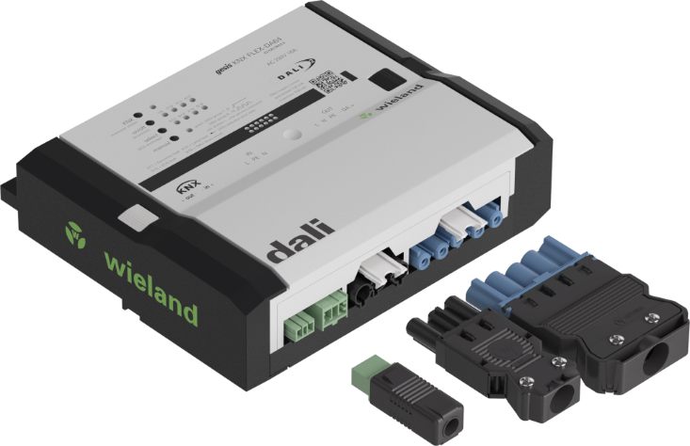

ABOUT WIELAND ELECTRIC

Wieland Electric, founded in Bamberg in 1910, is the inventor of safe electrical connection technology. Today, the family-owned company is one of the leading suppliers of safety and automation technology and has been the world market leader in the field of pluggable electrical installation for building services for over 30 years.

Wieland Electric supports customers worldwide on site as a competent service partner and solution provider. This is possible with around 1,600 employees and subsidiaries as well as sales organizations in over 70 countries. In addition to Wieland Electric GmbH, since 1998 STOCKO Contact GmbH & Co. KG has been part of the Wieland holding company since 1998.

The company's core industries include mechanical engineering, wind power, intralogistics and HVAC, as well as building and lighting technology. The broad portfolio includes components, products and solutions for electrical installation, connection technology, power distribution, safety technology and the control cabinet. In addition, Wieland Electric offers an extensive service and training program. With cross-industry experience, a wide range of products and numerous service offerings, the company has consistently developed from a component provider to a solution provider in recent years.

PRESS CONTACT
WIELAND ELECTRIC GMBH
Marketing Communication
Alexander Viertmann
Communications Manager
Brennerstraße 10 – 14
96052 Bamberg · Germany
E-Mail: alexander.viertmann@wieland-electric.com
Tel: +49 (951) 9324 - 316
Internet: www.wieland-electric.de

