PRESS RELEASE

IMMEDIATE SAFETY

Wieland Electric presents new emergency stop buttons with M12 connection for easy integration into plants and systems

In times of a shortage of skilled workers, technical devices that can be installed in a time-saving manner and, if possible, without the need for highly qualified personnel, come into their own. Wieland Electric has such a solution ready for safety technology in mechanical engineering and intralogistics: New emergency stop buttons are available for the safe, manual shutdown of machines and systems. Thanks to the M12 connection, they can be easily integrated into plants and systems using pre-assembled M12 standard cables.

With the introduction of the new emergency stop buttons, Wieland Electric not only meets the increasing demand for M12 connections in industry, but also expands its portfolio with ready-to-use variants that offer numerous advantages due to their plug & play installation. This includes reducing installation time and cabling effort as well as avoiding cabling errors during installation. Thanks to the compact and robust design, the emergency stop buttons can be installed in control cabinets and panels, but are also suitable - thanks to the IP65 and IP67 protection class design - for installation in the field where harsh ambient conditions prevail.

IMAGE MATERIAL

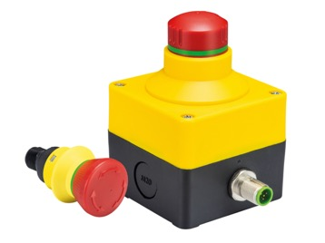
Whether surface or front panel mounting - with the new emergency stop buttons with M12 connection, Wieland Electric offers an economical solution for the simple and time-saving implementation of safety-relevant functions.

PRESS CONTACT
Marion Nikol
COMMUNICATION FOR INDUSTRY & TECHNOLOGY
Phone: +49 170 2731025
E-mail: info@intecsting.de

ABOUT WIELAND ELECTRIC

Wieland Electric, founded in Bamberg in 1910, is the inventor of safe electrical connection technology. Today, the family-owned company is one of the leading suppliers of safety and automation technology and has been the global market leader in the field of pluggable electrical installations for building technology for over 30 years.

Wieland Electric assists customers with on-site support all over the world as a capable service partner and solution provider. This is possible thanks to around 1,600 employees and subsidiaries as well as sales organizations in over 70 countries. In addition to Wieland Electric GmbH, STOCKO Contact GmbH & Co. KG has belonged to Wieland Holding since 1998.

The core industries of the company are mechanical engineering, wind power, and building and lighting technology. The broad portfolio includes components, products, and solutions for electrical installation, connection technology, power distribution, safety technology, and the control cabinet. In addition, Wieland Electric offers an extensive service and training program. With cross-industry experience, a great product diversity and numerous service offerings, the company has consistently developed from a component supplier to a solution provider in recent years.

