HANNOVER MESSE 2019 PRESS RELEASE

FOCUS ON COMBUSTION TECHNOLOGY

WIELAND ELECTRIC NOW OFFERS TAILORED SOLUTIONS FOR COMBUSTION PLANTS

Combustion technology is indispensable in the steel, glass, chemical, and cement industries, as well as in refuse incineration and paper manufacture. The requirements here in terms of plant safety and availability are not only especially high, they are also constantly changing. To offer the best possible support to mechanical engineers and plant operators in this area, Wieland Electric now provides complete system solutions optimally tailored to combustion technology – from connection technology to safety-related, interface, and control cabinet components, and through to advice, support, and training.

Whether thermoprocessing plants, steam boilers, or thermal oil heaters – the safe operation of combustion plants calls for practical solutions at every stage in the life of the machine or process. Wieland Electric is responding to this need with the establishment of the new “combustion technology” segment within its mechanical engineering range, offering complete safety solutions, efficient control cabinet components, and customized concepts here to suit any combustion application.

As a global technical contact and industry manager with many years of experience, Markus Kick is responsible for the ‘functional safety of automated heating systems’. Solution-oriented and future-proof engineering is his main focus: “From the terminal to the fail-safe heating controller to the World Wide Web with IoT and VPN, we address a huge variety of process technology requirements. With our decentralized solutions we are able to smartly connect the control level to the field level.”

Concrete applications include reliable temperature and ratio monitoring, pressure measurements, and also flow and quantity measurements. Complex processes can be implemented simply and compliantly, especially by using the new generation of analog modules on the samos PRO safety controller from Wieland. For this purpose, the controller and its software have been enhanced to include a special block library for combustion plants. This now means that digital as well as analog signals can be analyzed directly using TÜV-tested function blocks.
In addition, Wieland is on hand to provide plant operators and mechanical engineers with application support and advice as early as during the planning phase for all aspects, from the process sensor to the controller and through to the quick-acting shut-off valve. Seminars and training courses specifically designed for thermoprocessing plants complete the range of combustion technology solutions within the safety service.

(2,713 incl. spaces)

IMAGE MATERIAL

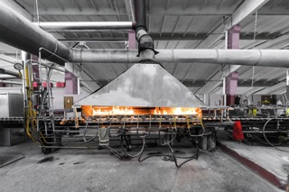

Wieland Electric now offers complete system solutions optimally tailored to combustion technology.

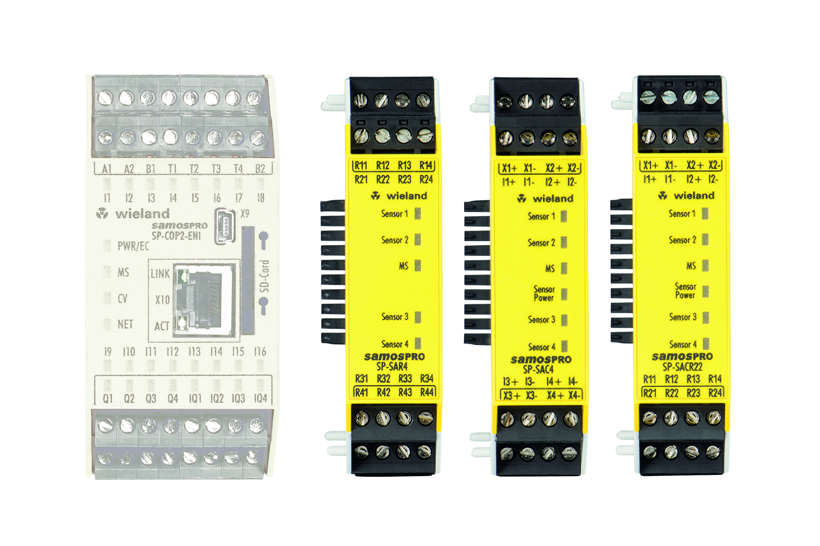

To offer the best possible support to mechanical engineers and plant operators in the area of heating systems, Wieland Electric has enhanced its samos PRO COMPACT safety controller and software to include a special block library for combustion plants.

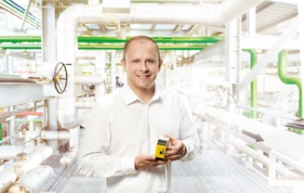

Markus Kick is responsible for the ‘functional safety of automated heating systems’ at Wieland as a global technical contact and industry manager.

PRESS DOWNLOAD SECTION
This press release can be downloaded from our website:
http://wie.li/pressehmi19

ABOUT WIELAND ELECTRIC

Wieland Electric, founded in Bamberg in 1910, is the inventor of safe electrical connection technology. Today, the family-owned company is one of the leading suppliers of safety and automation technology and has been the global market leader in the field of pluggable electrical installations for building technology for over 30 years.

Wieland Electric assists customers with on-site support all over the world as a capable service partner and solution provider. This is possible thanks to around 1,600 employees and subsidiaries as well as sales organizations in over 70 countries. In addition to Wieland Electric GmbH, STOCKO Contact GmbH & Co. KG has belonged to Wieland Holding since 1998.

The core industries of the company are mechanical engineering, wind power, and building and lighting technology. The broad portfolio includes components, products, and solutions for electrical installation, connection technology, power distribution, safety technology, and the control cabinet. In addition, Wieland Electric offers an extensive service and training program. With cross-industry experience, great product diversity, and numerous service offerings, the company has consistently developed from a component supplier into a solution provider in recent years.

YOUR PRESS CONTACT

WIELAND ELECTRIC GMBH
Marketing Communication
Brennerstraße 10 – 14
96052 Bamberg · Germany

E-mail: communications@wieland-electric.com
Internet: www.wieland-electric.com

