PRESS RELEASE

HUB FOR DIGITAL EDUCATION
The gesis® service pole from Wieland Electric supplies digital classrooms dece ntrally with energy and data

Digital transformation has picked up speed in the education sector in recent years. Schools and educational institutions face the challenge of expanding their digital capacities. At the same time, it is important to meet the increasing demands on the energy efficiency of rooms and buildings. Whether it's a smartboard, fast Internet, a networked classroom or efficient lighting control - electrical installation plays an important role in improving the infrastructure for digital teaching and smart room automation. The Franconian technology company Wieland Electric knows how this can be accommodated quickly, professionally and with sufficient space for future requirements.
"With our gesis® service pole we have an intelligent electrical installation solution for digital classrooms ready. The column acts as a hub here, supplying power and data to whiteboards, projectors, power sockets, lights, blinds and media interfaces. In contrast to distribution from the equipment room, the decentralized installation makes the pipe routes considerably shorter. This not only saves material, but also time and money," explains Jens Romberg, who is Project Manager North-Germany in the Installation & Infrastructure Building division at Wieland Electric. He also knows how strongly the digital transformation is currently being driven forward in the education sector: "The city of Hamburg, for example, recently released funding for the digitization of schools again. Of course, this includes investing in a future-proof electrical infrastructure."

Quick and easy installation
A major advantage of the Wieland installation column, which is suitable for both existing and new buildings, is its high degree of prefabrication: the column is delivered configured, tested and, if desired, with programmed room automation. On site, thanks to the gesis® connector system, it is easily and quickly mounted according to the plug & play principle, connected to the existing installation and put into operation. This ensures smooth, time-saving processes, which in turn reduces the workload on electrical installation company personnel.

Thanks to the large installation space as well as a distribution panel that offers space for up to 126 PD depending on the variant, there is sufficient installation space for future adaptations and expansions. The design, in turn, can be customized, both in terms of dimensioning and equipment with fronts and doors as well as electrical and electronic installations. In addition, Wieland Electric has also considered the topic of safety: Through different user levels - one freely accessible, one lockable for teachers, and a separate level for the specialist – the gesis® service pole offers protection against manipulation and secures access for the various users.

IMAGE MATERIAL

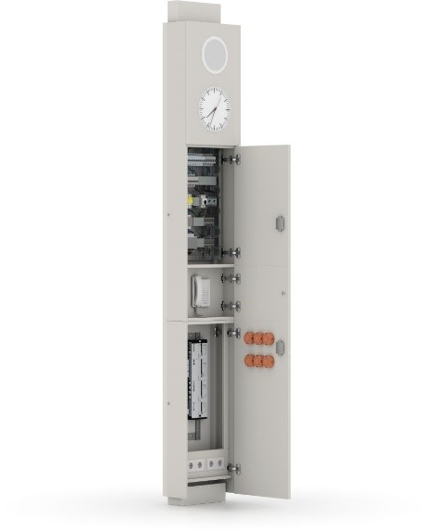
The gesis® service pole from Wieland Electric makes it possible to safely and professionally accommodate the electrical installation required for digitalization and smart room automation in the classroom.

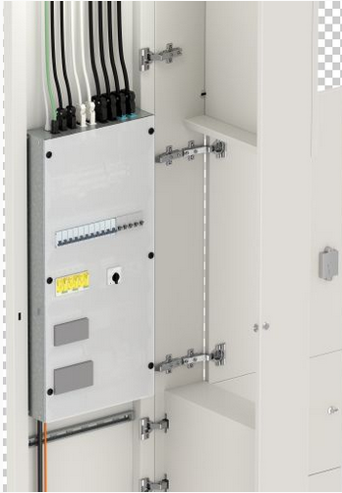

Decentralized installation in the classroom significantly shortens wiring distances, saving materials, time and money.

PRESS CONTACT
Magdalena Montagna
Content Marketing & Communication
Phone: ++49 (951) 9324 - 316
E-mail: magdalena.montagna@wieland-electric.com

ABOUT WIELAND ELECTRIC

Wieland Electric, founded in Bamberg in 1910, is the inventor of safe electrical connection technology. Today, the family-owned company is one of the leading suppliers of safety and automation technology and has been the global market leader in the field of pluggable electrical installations for building technology for over 30 years.

Wieland Electric assists customers with on-site support all over the world as a capable service partner and solution provider. This is possible thanks to around 1,600 employees and subsidiaries as well as sales organizations in over 70 countries. In addition to Wieland Electric GmbH, STOCKO Contact GmbH & Co. KG has belonged to Wieland Holding since 1998.

The core industries of the company are mechanical engineering, wind power, and building and lighting technology. The broad portfolio includes components, products, and solutions for electrical installation, connection technology, power distribution, safety technology, and the control cabinet. In addition, Wieland Electric offers an extensive service and training program. With cross-industry experience, a great product diversity and numerous service offerings, the company has consistently developed from a component supplier to a solution provider in recent years.

