HANNOVER MESSE 2019 PRESS RELEASE

OPERATION AND VISUALIZATION IN LARGE FORMAT

HMI ECO TOUCH PANELS FROM WIELAND NOW ALSO AVAILABLE IN 12.1 AND 15 INCHES

The HMI Eco touch panels from Wieland have grown. The powerful and robust HMI panels are now also available in 12.1 and 15 inches – to provide optimum support for sophisticated and scalable visualizations. Mechanical engineers and plant manufacturers also have the option to purchase panels with their own front design, including logo and color of their choice, to increase the prestige of their products and strengthen their spare parts business. The touch panels also allow a seamless exchange of data with both the samos Pro Compact safety controller and common PLCs.

Just like the HMI Eco touch panels available in 4.3, 7, and 10 inches, which were launched back in the fall of 2018, the new 12.1 and 15-inch models are extremely robust operating devices. The screen is certified according to protection class IP66, protecting the device against strong water jets as well as any other moisture.

The large HMI Eco touch panels are particularly suited to applications such as presses, large plants in the process industry, test benches, or materials processing machines with several operators working on them. Usage under extreme temperatures of -20 to +60 degrees Celsius also opens up additional fields of application such as elevators or refrigerated warehouses.

Their universal interfaces and compatibility with more than 40 PLC and device manufacturers make HMI Eco touch panels very versatile. Universal interfaces for Ethernet, USB host, and USB client connections are available, along with a serial interface. The new HMI panels from Wieland are also the ideal complement to the samos Pro Compact safety controller. They enable simple visualization via the hmiPLAN software and guarantee a smooth exchange of data with the samos PLAN 6 safety software.

(2,034 incl. spaces)

IMAGE MATERIAL

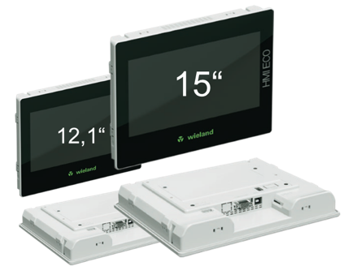

For an even better overview: The powerful and robust HMI Eco touch panels from Wieland are now also available with a diagonal screen size of 12.1 and 15 inches.

PRESS DOWNLOAD SECTION
This press release can be downloaded from our website:
http://wie.li/pressehmi19

ABOUT WIELAND ELECTRIC

Wieland Electric, founded in Bamberg in 1910, is the inventor of safe electrical connection technology. Today, the family-owned company is one of the leading suppliers of safety and automation technology and has been the global market leader in the field of pluggable electrical installations for building technology for over 30 years.

Wieland Electric assists customers with on-site support all over the world as a capable service partner and solution provider. This is possible thanks to around 1,600 employees and subsidiaries as well as sales organizations in over 70 countries. In addition to Wieland Electric GmbH, STOCKO Contact GmbH & Co. KG has belonged to Wieland Holding since 1998.

The core industries of the company are mechanical engineering, wind power, and building and lighting technology. The broad portfolio includes components, products, and solutions for electrical installation, connection technology, power distribution, safety technology, and the control cabinet. In addition, Wieland Electric offers an extensive service and training program. With cross-industry experience, great product diversity, and numerous service offerings, the company has consistently developed from a component supplier into a solution provider in recent years.

YOUR PRESS CONTACT

WIELAND ELECTRIC GMBH
Marketing Communication
Brennerstraße 10 – 14
96052 Bamberg · Germany

E-mail: communications@wieland-electric.com
Internet: www.wieland-electric.com

