PRESS INFORMATION

Fully charged towards the future - Wieland Electric presents a solution for charging electric vehicles using the claim "The Innovation Behind”

With the podis® flat cable system, Wieland Electric offers an innovative and decentralized solution for supplying energy to charging stations for electric cars. With the decentralized supply technology, wallboxes can be supplied with energy easily and quickly, and with significantly less effort and material consumption compared to a conventional installation.

Decentralization as the key to the supply

The podis® energy bus system is ideal for distributing power to charging stations. With this decentralized energy distribution system, a large number of charging stations can be connected with just one supply line.
This saves time during installation, reduces the amount of material required and significantly reduces the dimensions of the distribution cabinet.
The connection components for the feed-in or the energy tap-off can be placed at any point of the
power bus. The fast and flexible positioning of the connection modules is made possible with the
piercing contacts of the podis® components. As a result, conventional time-consumers such as cutting, stripping and terminating become completely obsolete.

Flexibly supplied

The feed into the energy bus can be set completely flexibly and freely - even centrally, which enables an ideal balance of the load on the energy bus. As a result, the number of charging stations fed can be increased on a line section without overloading the flat cable. The tap-off modules for the power supply can be placed anywhere at any time. This also makes extensions to the installation possible, with ease and without great expense. The special feature is that these tap-off modules are available both for fixed installation and in the pluggable version. This brings decisive advantages when a charging station has to be replaced.

Technical features

The podis® cable is a 5-core flat cable system with a 16mm² cable cross-section. Connection cross-sections are possible with up to 16mm² in the center feed and with up to 70mm² in the end feed. A current load according to IEC is possible with up to 100A, free in air. Dielectric strength is up to 690 V according to IEC and up to 600 V according to NEC.
Technical features

IMAGE MATERIAL
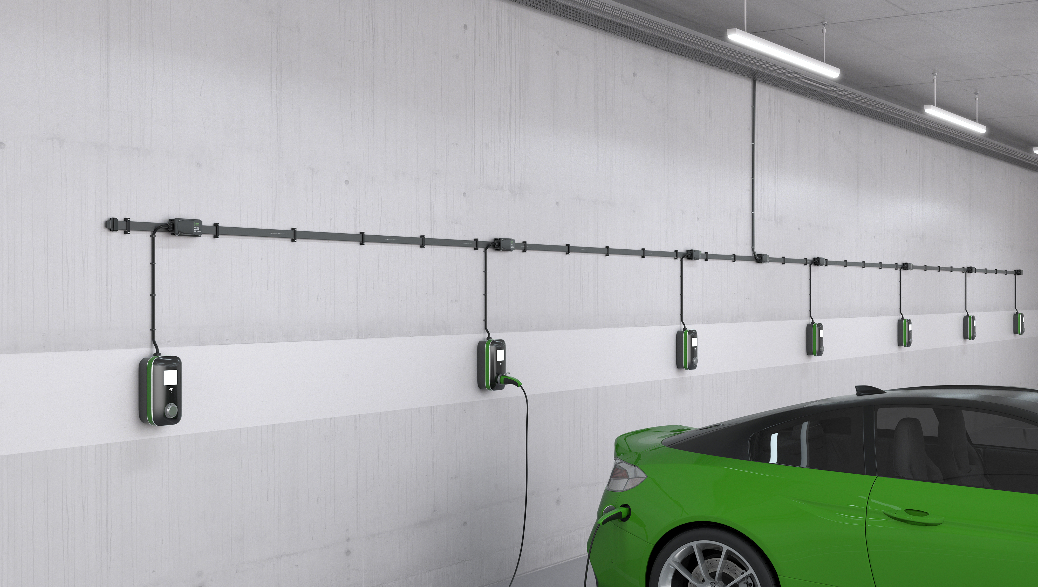
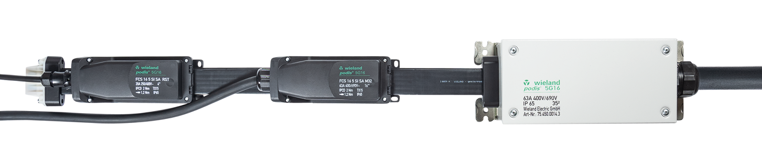

ABOUT WIELAND ELECTRIC

Wieland Electric, founded in Bamberg in 1910, is the inventor of safe electrical connection technology.
Today, the family-owned company is one of the leading suppliers for safety and automation technology
and has been the world market leader in the field of pluggable electrical installation for building technology for over 30 years.

Wieland Electric supports customers worldwide on site as a competent service partner and solution provider.
This is possible with around 1,600 employees and subsidiaries as well as sales organizations in over 70 countries. In addition to Wieland Electric GmbH, since 1998 STOCKO Contact GmbH & Co. KG has been part of the Wieland holding company since 1998.

The company's core industries include mechanical engineering, wind power, intralogistics and HVAC, as well as building and lighting technology.
The broad portfolio includes components, products and solutions for electrical installation, connection technology, power distribution, safety technology and the control cabinet. In addition, Wieland Electric offers a comprehensive service and training program. With cross-industry experience, a wide range of products and numerous service offerings, the company has consistently developed from a component provider to a solution provider in recent years.

PRESS CONTACT

WIELAND ELECTRIC GMBH
Alexander Viertmann
Marketing Communication
Brennerstraße 10 – 14
96052 Bamberg · Germany

E-Mail: communications@wieland-electric.com
Internet: www.wieland-electric.de

