MAY 2021
PRESS INFORMATION

INNOVATION BY MODULAR DESIGN

WIELAND ELECTRIC PRESENTS MOLA®, A NEW
DEVICE CONNECTOR FOR THE RST® MINI SYSTEM

The new device connector clearly sets a signal for the future in the area of pluggability, as there is no comparable system on the market.

The special features of the new product all revolve around flexible and simple assembly. This is achieved by double conductor connections, which are equipped with a push-in spring, the possibility to prefabricate the components at separate locations and last but not least also by the suitability for automatic wiring. Thus, installations with a high degree of protection are significantly simplified and can be individually adapted to any application.

MOLA® has been optimized especially with luminaire manufacturers in mind, but is also suitable for installation in other areas of application. Thus, areas such as motors, heaters and controls in general can also benefit from the flexibility of the connection. MOLA® is available in 2-, 3- 4- and also 5-pole versions and is designed for through holes of 20 mm, which simplifies a conversion to MOLA®, thus a wide range of projects and application areas can be covered.

The modular design ensures that, as mentioned at the beginning, the internal wiring harness and the housing can be prefabricated separately. For special requirements, an optional contact sealing can provide additional protection against moisture penetration, so that MOLA® can be used even under the most adverse conditions without any problems.

IMAGE MATERIAL

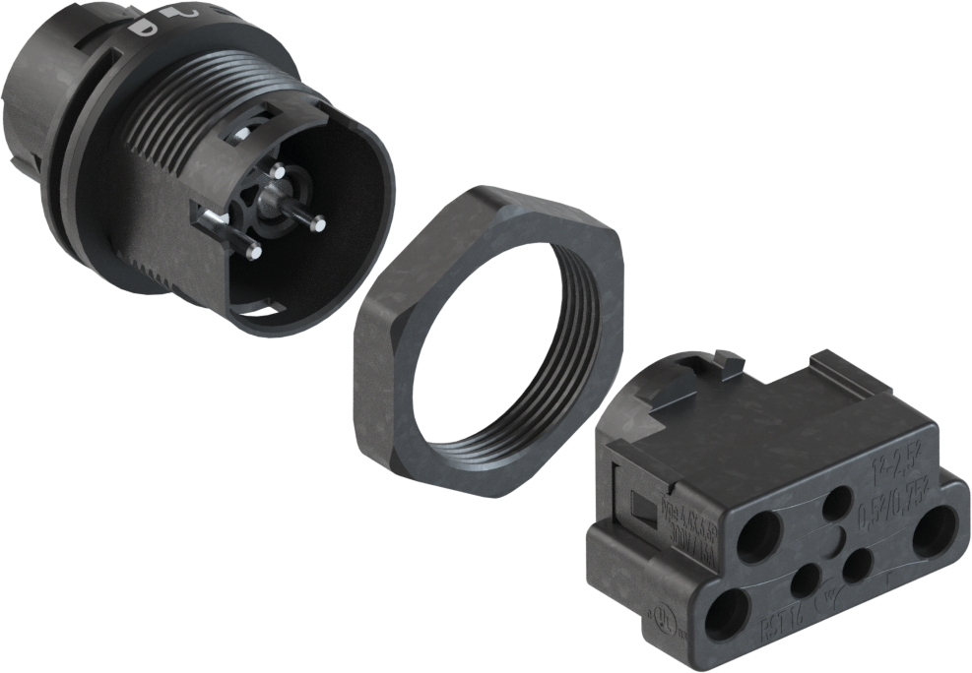
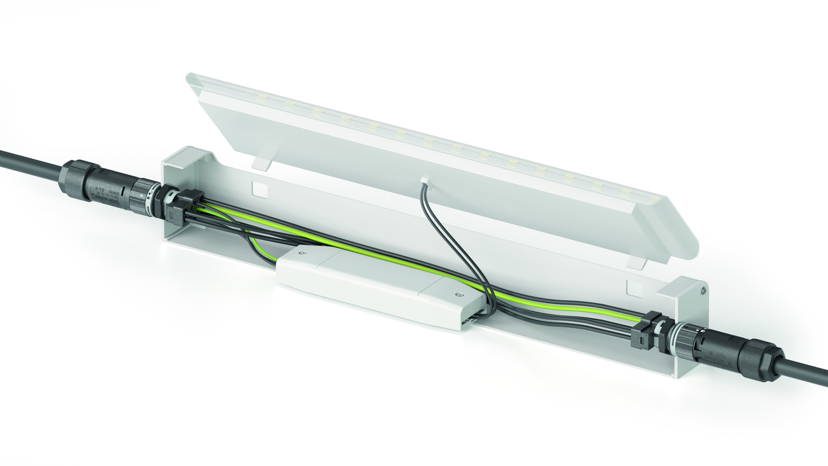

ABOUT WIELAND ELECTRIC

Wieland Electric, founded in Bamberg in 1910, is the inventor of safe electrical connection technology.
Today, the family-owned company is one of the leading suppliers for safety and automation technology
and has been the world market leader in the field of pluggable electrical installation for building technology for over 30 years.

Wieland Electric supports customers worldwide on site as a competent service partner and solution provider.
This is possible with around 1,600 employees and subsidiaries as well as sales organizations in over 70 countries. In addition to Wieland Electric GmbH, since 1998 STOCKO Contact GmbH & Co. KG has been part of the Wieland holding company since 1998.

The company's core industries include mechanical engineering, wind power, intralogistics and HVAC as well as
building and lighting technology The broad portfolio includes components, products and solutions for electrical installation, connection technology, power distribution, safety technology and the control cabinet. In addition, Wieland Electric offers an extensive service and training program. With cross-industry experience, a wide range of products and numerous service offerings, the company has consistently developed from a component provider to a solution provider in recent years.

PRESS CONTACT
WIELAND ELECTRIC GMBH
Alexander Viertmann / Marketing Communication
Telefon: +49 951 9324 316
E-Mail: communications@wieland-electric.com
Internet: www.wieland-electric.com

