OCTOBER 2022
PRESS INFORMATION

WIELAND ELECTRIC SHOWS STABLE GROWTH

HIGH ORDER VOLUME AND VERY GOOD SALES PERFORMANCE CONTINUE IN THE THIRD QUARTER

Rising energy costs, supply bottlenecks, inflation - the economic situation in Germany is and will remain tense. Nevertheless, the Franconian technology company Wieland Electric is optimistic about the future. According to the management, this is due to a continued high order volume and a very good sales development. "Fortunately, the first two successful quarters have been followed by an equally good third quarter," reports Managing Director Dr.-Ing. Börne Rensing. "Our goal is to sustain this positive development both in the coming months and beyond 2022. The acute global challenges and changes of our time are indeed very demanding. This makes it all the more important to remain vigilant, act with foresight and join forces to drive Wieland's further development and pursue our growth targets."
His Managing Director colleague Dr. Christian Wahlers adds: "If you want to put this in figures, we were able to achieve double-digit percentage sales growth up to the third quarter compared with the same period of the previous year. As was the case last year, high investments were made in the sites as well as in the Bamberg headquarters, both in machinery and equipment, but also in our employees."

IMAGE MATERIAL
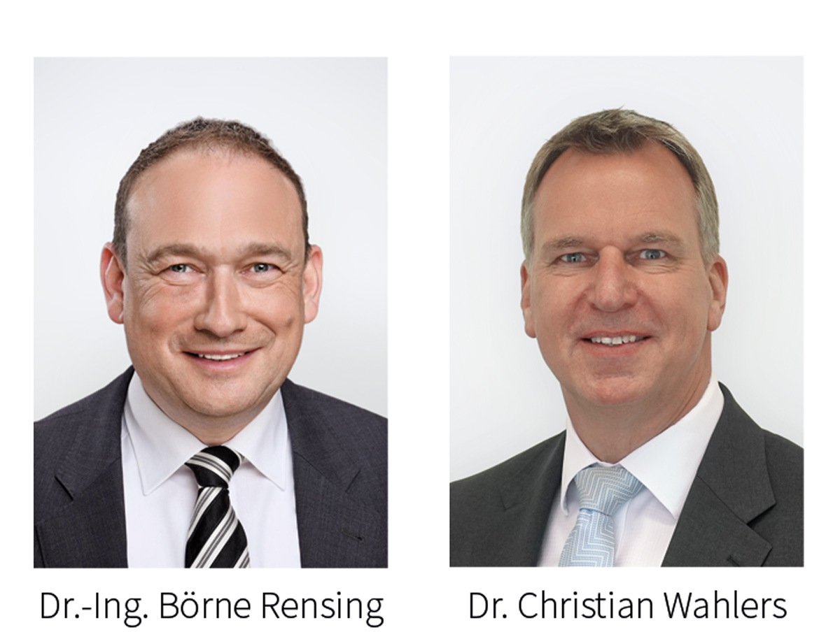

Dr.-Ing. Börne Rensing und Dr. Christian Wahlers, Managing Directors Wieland Electric

ABOUT WIELAND ELECTRIC

Wieland Electric, founded in Bamberg in 1910, is the inventor of safe electrical connection technology.
Today, the family-owned company is one of the leading suppliers for safety and automation technology
and has been the world market leader in the field of pluggable electrical installation for building technology for over 30 years.

Wieland Electric supports customers worldwide on site as a competent service partner and solution provider.
This is possible with around 1,600 employees and subsidiaries as well as sales organizations in over 70 countries. In addition to Wieland Electric GmbH, since 1998 STOCKO Contact GmbH & Co. KG has been part of the Wieland holding company since 1998.

The company's core industries include mechanical engineering, wind power, intralogistics and HVAC, as well as building and lighting technology. The broad portfolio includes components, products and solutions for electrical installation, connection technology, power distribution, safety technology and the control cabinet. In addition, Wieland Electric offers an extensive service and training program. With cross-industry experience, a wide range of products and numerous service offerings, the company has consistently developed from a component provider to a solution provider in recent years.

PRESS CONTACT
WIELAND ELECTRIC GMBH
Alexander Viertmann / Marketing Communication
Phone: +49 951 9324 316
E-Mail: communications@wieland-electric.com
Internet: www.wieland-electric.com

