Individual visualization with a robust design

Wieland expands its portfolio with high-performance HMI ECO touch panels in a high protection class

In order to meet growing requirements for modern mechanical engineering, Wieland Electric has adopted high-performance HMI panels in its product portfolio. The winning feature is the optional customization of design: users can order the device in a front design and in a color of their choice. Individually labeled, the HMI panels can be easily and quickly allocated to each machine and plant type. In addition, they provide a perfect supplement to the samos PRO COMPACT safety control system from Wieland and enable easy visualization along with smooth data exchange.

Intelligent touch panels are the state of the art today in terms of easy control and monitoring of machines and plants. For reliable use, even under extreme environmental conditions, Wieland now offers extremely robust operating devices with its new HMI ECO touch panels. The screen is certified according to protection class IP66, protecting the devices against strong water jets as well as any other moisture. Thanks to application under extreme temperatures of -20 to +60 degrees Celsius, they also open up additional fields of application such as elevators or refrigerated warehouses.

Thanks to their universal interfaces and compatibility with more than 40 PLC and device manufacturers, HMI ECO touch panels offer versatile uses. They are available in standard sizes of 10, 7 and 4.3 inch. The HMI ECO touch panels feature an extremely robust design and offer universal interfaces for Ethernet, USB host and USB client interfaces, along with a serial interface.

The new HMI panels from Wieland also provide the samos PRO COMPACT safety control as an optimal supplement. In this, they enable easy visualization with hmiPLAN software and guarantee smooth data exchange with samos PLAN 6 safety software.

(xxxx with spaces)

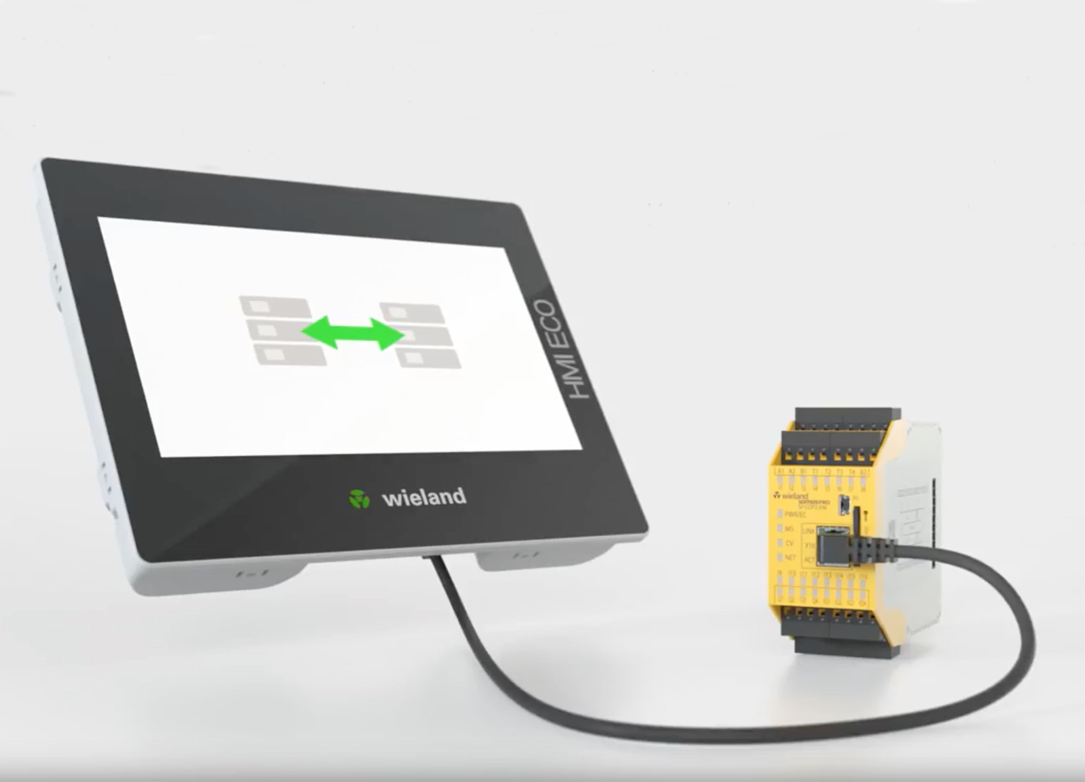

Reliable technology in an appealing design: With the robust HMI ECO touch panels from Wieland, machines and plants can be easily controlled and monitored.

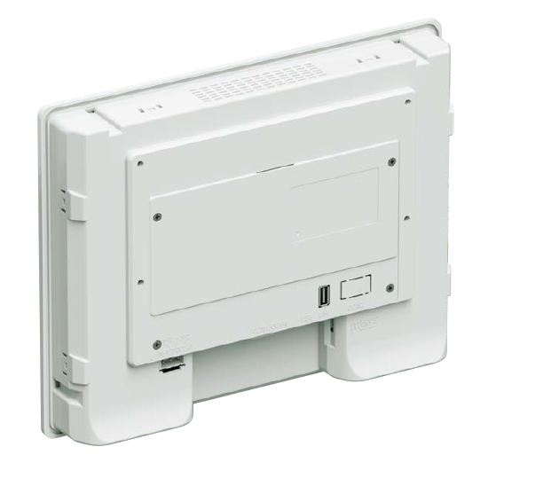
Communication is easy via Ethernet and Modbus TCP.

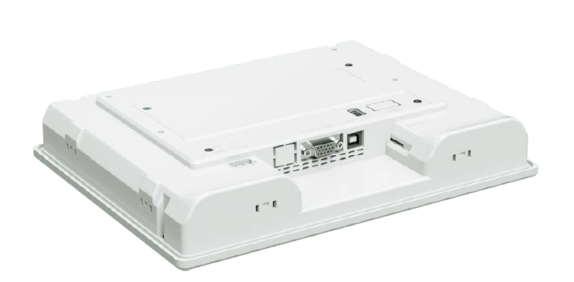

Fast, flexible and easy: The programming and visualization of machines and plants can be carried out in a straightforward procedure with the help of hmiPLAN software via Ethernet and USB.

PR Contact

Wieland Electric GmbH
Roland Gagel
Marketing
Brennerstraße 10 – 14
96052 Bamberg, Germany

Email: presse.de@wieland-electric.com
Internet: www.wieland-electric.com

